Health Systems Benchmarking Tool (HSBT) User Manual

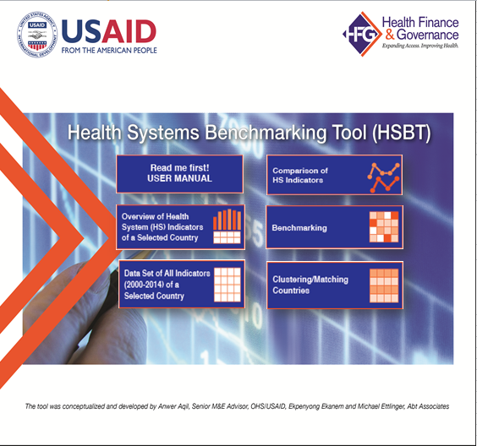

Anwer Aqil and Elizabeth Lugten
Office of Health Systems, USAID
July 1, 2016

Health Systems Benchmarking Tool (HSBT) User Manual
Contents
Acknowledgement 3
Background 4
Menu Overview 6
Database Codebook: 7
Overview of the Health System (HS) Indicators of a Selected Country 10
Introduction: 10
Data set of all Indicators (2000-2014) of a Selected Country 13
Introduction: 13
Comparison of HS Indicators 16
Introduction 16
Benchmarking Countries on HS Indicators 23
Introduction 23
Some common steps for benchmarking 24
Take home Messages 30
Benchmarking using fixed value 30
Take home message: 33
Benchmarking using mean 35
Take home message: 37
Benchmarking using median 39
Take home message: 40
Benchmarking using quartile 42
Take home messages: 43
Clustering/Matching Countries 45
Introduction 45
Clustering using k-mean 51
Select indicator option 52
Select country option 54
Clustering using k-median 62
Take home messages: 67

Acknowledgement
I would like to appreciate Ms. Karen Cavanaugh, Director, USAID Office of Health Systems (OHS), who provided the technical leadership in developing the health system benchmarking tool (HSBT). Without her intellectual guidance and support, completion of this task would have not been possible.
Kathryn Panther, Deputy Director, USAID Office of Health Systems (OHS) was always there to listen and guide the management process for developing HSB tool

Special thanks to Sweta Saxena and Trenton White, OHS, who participated in the planning meetings, reviewed the tool and provided useful inputs.

I am grateful to Ms. Elizabeth Lugten, who coauthored user instruction manual with me and edited the manual.

Jason Wucinski, Senior Information Systems Technical Adviser, Office of Policy, Planning and Programs, deserved special thanks for testing the Excel functions and provided suggestions for future improvements in the tool.

Ekpenyong Ekanem, Associate M&E Research Scientist, Abt Associates—HFG project activity manager for HSBT and Micheal Ettinger, have been instrumental in developing the excel macros for the tool and deserved equal credit.

I take responsibility for conceptualizing the tool, selecting the indicators, guiding the tool development process and its analysis functions as well as accountable for any omission and will make all efforts best to my abilities to continuously improve the tool in near future.
Anwer Aqil,
Senior M&E Advisor, Activity manager for HSBT
Office Of Health Systems
BGH/USAID—
aaqil@usaid.gov

Background
The Health System Benchmarking Tool is developed for health system managers/administrators/ planners, policy makers and monitoring and evaluation experts. It can provide answers to where a country’s health system stands against neighboring countries, within regions and countries with similar socio-economic, demographic, and gender empowerment characteristics. It can also inform users about strengths in a country’s health system and what can be learned from other countries for continuous improvement.

After a review of the literature, no global tools were found for public use to benchmark health system functions, outcomes and impacts. The Health System Benchmarking Tool fulfills this gap allowing countries to have a more complete picture of its health system indicators. Donors and country health planners/administrators need health system performance assessments not only for monitoring whether the health system is producing services, outcomes, and impacts as planned, but also for identifying opportunities for improvements, investments, and decreasing waste. In addition, donors and country health planners compare health system performance of countries and administrative units to identify the best and the worst performing countries and ascertain systemic and special causes underlying performance to make investment, planning, and management decisions.

Objectives
- Display a comprehensive data set of 142 countries on socio-economic, demographic and gender and health system functions, outcomes and impact indicators covering a period of 2000-2014
- Provide an overview of illustrative health system indicators
- Compare indicator(s) over time, by countries, countries within regions, or countries by income groups
- Benchmark health system indicator(s) using various parameters
- Cluster countries using socio-economic characteristics into groups with similar characteristics

Uses
- Global comparison of health systems indicators
- Recognize trends in health system indicators from 2000 to 2014
- Distinguish patterns in types of health service coverage by countries
- Identify countries with best and worst health system indicators by region, income group, or a selected group of countries
- Observe the socio-economic and demographic context of health system indicators
- Compare health system contextual indicators with health system indicators
- Develop policy and plan programming from analysis
- Import available data to any statistical software for inferential analysis

Tool composition
The tool comprises of a dataset of 140 countries with their socio-economic, demographic and gender empowerment as well as health system functions, outcome and impact indicators focusing on maternal and child health, malaria, TB and HIV/AIDS services. The data sources are from internationally recognized institution such as WHO, World Bank, DHS, OECD, UNSTAT, ILO, UNDP, Pew Research Center. The countries were subgroups under WHO geographical regions and World Bank classification of countries by income. We have provided an option to analyze countries under USAID Ending preventable child and maternal deaths (EPCMD) initiative.

Interactive tool
The tool is interactive. The user has to come up with an analysis question before using the tool. Some of the illustrative analysis questions could be:
- Is there a change in a health system indicator over time in a given country?
- Did the selected health system indicators trends differ from each other in a given country?
- Did the countries differ on selected indicators over time?
- Which selected countries are below and above the selected parameter for given indicator(s)?
- Which selected countries share similar socio-economic indicators?
- Which country is a “positive deviant” on specific health system indicator (s) among the selected countries?
Once the analysis questions are ready, the analyst can use the appropriate tab in MENU to select countries and indicators for analysis. We have provided specific instructions under each tab in different sections of the manual and how to interpret the analysis charts/tables.

Limitations
- Comparative analysis within country is only possible with national level data
- Complete set of indicators are not available for all countries making it difficult to compare some countries
- Missing data creates problems for analysis using the clustering function. If the selected countries have missing indicators, the analysis function treats the country as not having any data, thus reducing the number of countries to cluster.

Organization of the manual
The manual is divided into five sections based on types of analyses that can be performed. . Each section includes a step by step guidance to perform the analysis with the tool and interpretation of the analysis output. The first section is about getting an overview of the health system predefined illustrative functions, outcomes and impact indicators. Second section deals with providing a full data set of a selected country from 2000 to 2014. It provides some information of the missing data for that country. Comparison of health system indicators over time is discussed under third section. Instructions on how to conduct benchmarking are provided in section four. Lastly, we have provided guidance on clustering function, which should be used to group countries with similar socio-economic characteristics and later used for comparison. It allows controlling for effects of socio-economic characteristics on health system functions, outcomes and impact.
Citation: Aqil, A., Ekanem, E., Ettinger, M. (2016) Health System Benchmarking Tool; USAID/Office of Health Systems; Abt Associates

Menu Overview

Clicking this tab will presents all indicators in an Excel spreadsheet of indicators from 2000-2014 for 142 countries.

Clicking this tab will provide an overview of the pre-specified health system functions, outcomes and impact indicators by selecting a country of interest.

Clicking this tab will initiate the analysis process for benchmarking selected indicators by countries.
Clicking this tab will start analysis process for clustering/grouping countries sharing similar socio-economic characteristics.

Clicking this tab will provide an overview of the pre-specified health system functions, outcomes and impact indicators for a country of interest.

By clicking this tab, you will open a user manual.

Home page to select analyses
Clicking this excel sheet will show the data set, which will be used for different kinds of analyses
Familiarize yourself with Indicators and their definitions, sources by clicking this excel sheet codebook
After completing the analysis function, output will be displayed in a new excel sheet.

Database Codebook:
More information regarding the indicators, their definitions, and sources of data can be found in the Codebook tab of the Benchmarking Tool. It also describes the format of the data, labels, and blank and missing data.You can also find more detailed information about how to interpret data from each indicator. Click “Menu” to go back to the Menu page.
DATABASE CODEBOOK
This contains descriptive information for acronyms and data sources detail, each data field, disaggregates and other information.
DATABASE CODEBOOK
This contains descriptive information for acronyms and data sources detail, each data field, disaggregates and other information.
Sources
The following sources are as indicated in the Database:
1. WHO/GHO data Repository: This World Health Organization Global Health Observatory Data Repository provides access to over 1000 indicators on priority health topics. In addition, the GHO provides on-line access to WHO's annual summary of health-related data for its member states; i.e. the World Health Statistics. For the purposes of this Database, data obtained was downloaded April 21-May 31 2015. See http://apps.who.int/gho/data/node.main
2. World Bank World Development Indicators (WB-WDI): This is the primary World Bank collection of development indicators, compiled from officially-recognized international sources. It presents the most current and accurate global development data available, and includes national, regional and global estimates. Data extracted was last Updated: 04/14/2015. See more details at: http://info.worldbank.org/governance/wgi/index.aspx#home
3. World Bank World Governance Indicators (WB-WGI): The Worldwide Governance Indicators (WGI) are a research dataset summarizing the views on the quality of governance provided by a large number of enterprise, citizen and expert survey respondents in industrial and developing countries. These data are gathered from a number of survey institutes, think tanks, non-governmental organizations, international organizations, and private sector firms. See more detail and disclaimer information from http://info.worldbank.org/governance/wgi/index.aspx#home
4. Organization for Economic Co-operation and Development (OECD) Social Institutions and Gender Index (SIGI): This represents variables that combine qualitative and quantitative data to capture the formal and informal laws, attitudes and practices that restrict women’s and girls’ access to rights, justice and empowerment opportunities. The variables span all stages of a woman’s life in order to show how discriminatory social institutions can interlock and bind them into cycles of poverty and disempowerment. See more details from http://genderindex.org/data and http://stats.oecd.org/index.aspx?datasetcode=GIDDB2014#
5. CIA The World factbook: Data on population compares estimates from the US Bureau of the Census based on statistics from population censuses, vital statistics registration systems, or sample surveys pertaining to the recent past and on assumptions about future trends. See https://www.cia.gov/library/publications/the-world-factbook
6. Demographic and Health Surveys (DHS): This data provides information for a wide range of monitoring and impact evaluation indicators in the areas of population, health, and nutrition. Pooled - See more at: http://dhsprogram.com
7. The World Bank Living Standards Measurement Study (WB-LSMS): is a household survey program with a goa of facilitating the use of household survey data for evidence-based policymaking. See http://econ.worldbank.org/WBSITE/EXTERNAL/EXTDEC/EXTRESEARCH/EXTLSMS/0,,contentMDK:23617082~pagePK:64168445~piPK:64168309~theSitePK:3358997,00.html
8. UNICEF Data: This represents data related to children and women collected through Multiple Indicator Cluster Surveys (MICS), an international household survey programme. See more details at http://data.unicef.org
9. Millennium Development Goals Indicators (UNSTATS): This dataset presents the official data for indicators to measure progress towards the Millennium Development Goals. The data and analyses are the product of the work of the Inter-agency and Expert Group (IAEG) on MDG Indicators, coordinated by the United Nations Statistics Division. For more details see http://unstats.un.org/UNSD/MDG
10. Pew Research Center: This data originates from the Pew-Templeton Global Religious Futures project which analyzes religious change and its impact on societies around the world. See http://www.globalreligiousfutures.org/
11. United Nations Development Programme Gender Inequality Index: A composite measure reflecting inequality in achievement between women and men in three dimensions: reproductive health, empowerment and the labour market. See Technical note 3 at http://hdr.undp.org/en for details on how the Gender Inequality Index is calculated.
12. Essential Medicines and Health Products Information Portal: The WHO Essential Medicines and Health Products Information Portal supports efforts to improve access to essential medicines and health products by making related, full-text articles available online. http://apps.who.int/medicinedocs/en/m/abstract/Js20052en/
13. WHO/Essential Medicines and Health Products Information Portal. http://apps.who.int/medicinedocs/en/m/abstract/Js20052en/
14. International labor organization Social Security Database - Programmes and mechanisms http://www.ilo.org/dyn/sesame/ifpses.socialdatabase
15. WHO Programme for International Drug Monitoring/Uppsala Monitoring Centre (UMC): In 1968, during the 16th World Assembly the 16.36 resolution called for “a systematic collection of information on serious adverse drug reactions during the development and particularly after medicines have been made available for public use”. This led to the formation of the WHO Programme for International Drug Monitoring (PIDM). WHO promotes PV at country level. Initially the WHO PIDM members consisted of 10 countries. As of January 2016, 123 countries have joined the WHO PIDM, and in addition 28 associate members are awaiting full membership.http://www.who-umc.org/DynPage.aspx?id=100653&mn1=7347&mn2=7252&mn3=7322&mn4=7442Format
All Data, except otherwise indicated are numeric continuous variables and expressed as absolute numbers or percentages. Some indicators, when expressed as ranges or relative to a value to accommodate a margin of error e.g. <1 000, were adjusted accordingly to absolute values for analysis purposes. Those indicators are thus represented:
Variable labels
See Table below for details on variables as contained in the database
Blanks and Missing Data
Blank cells indicate unavailable data as obtained from the listed source for that particular year.

Overview of the Health System (HS) Indicators of a Selected Country

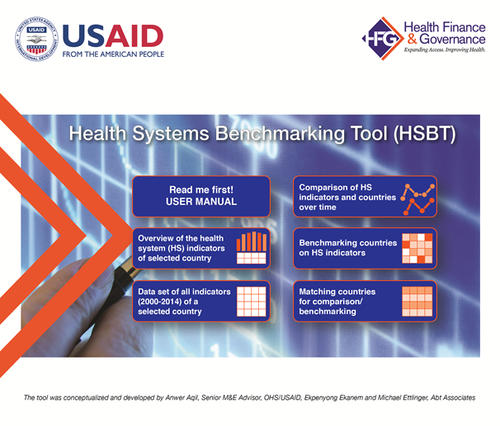
By clicking this tab from the meu, a new window will appear to select a country

Introduction:

Select the Overview of the health system indicators of selected country tab if you are interested in an overview of a particular country health system and its contextual factors. Examples of data presented by health system functions include total expenditure on health as a percentage of GDP (Financing), Government effectiveness (governance), nursing and midwifery (Human resource for health) and median availability of medicines (Medicine/vaccine and technology). Contraceptive prevalence, ANC, and DPT3 coverage reflect health system outcomes, while child under 5 mortality and maternal mortality represent impact indicators.

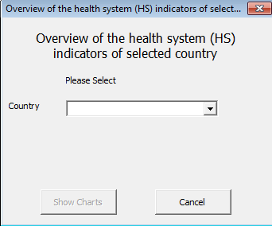
Use the drop down to select the country you are interested in.

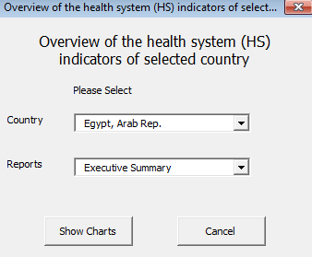
Once the country is selected, report type: Executive Summary will appear automatically.
After that click Show Charts to generate report.

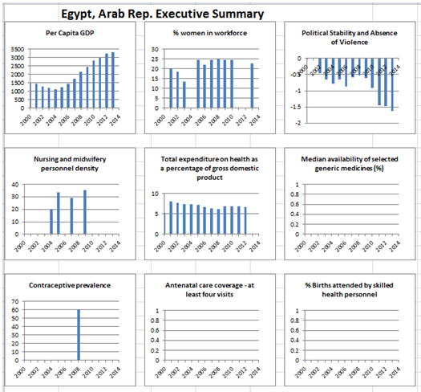
The summary chart will appear in a new excel sheet along with table of data (see below).

Each chart displays data points for specific indicators from 2000-2014, which can be interpreted as a trend in that indicator over time, if multiple data points are available. You can make statements about indicators in each chart. For example, a comparison can be made between indicators such as per capita GDP and total expenditure on health or availability of nurses and midwifery and contraceptive prevalence.
Note: Please note that if the data is not available for selected indicator then the chart would be empty.

Data set of all Indicators (2000-2014) of a Selected Country

By clicking this tab from the menu, a window will appear to select a country.

Introduction:

This function displays the complete data set of a selected country from 2000-2014 similar to the Master database sheet, except that it is specific to the selected country. This allows for an overview of available and missing data. A decision on what kind of data analyses are possible with in a selected country can be made based on this information. You can also use this function to get information on a specific indicator for a specific year or multiple years quickly, if the data is available.
Data can be imported to other statistical software to conduct various analyses or get better a visualization of data.
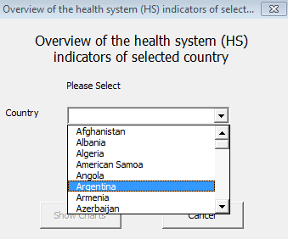
Use the drop down menu to select the country.

Once the desired country is selected then click “Show Chart”.

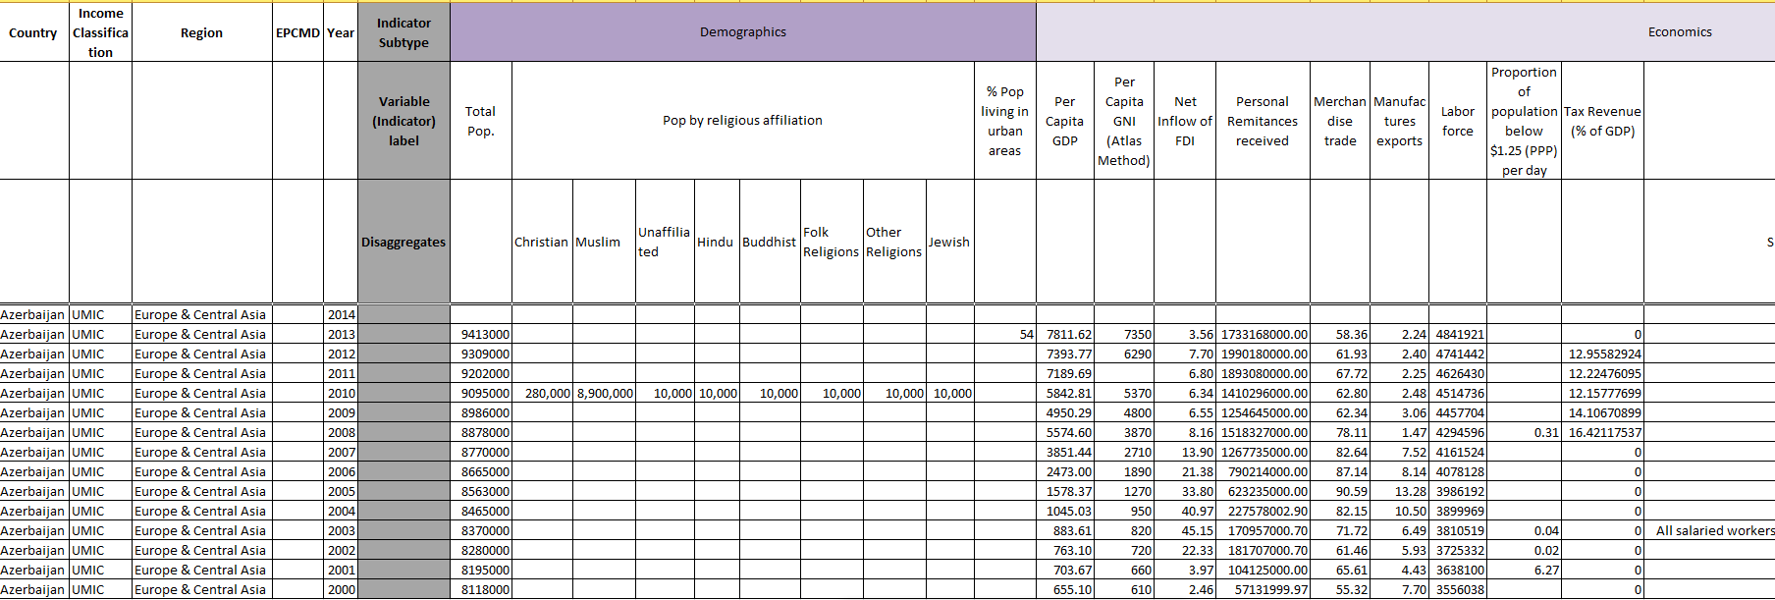
The dataset for a specific country will be displayed for your review.

The Excel output on the previous page provides data on all indicators collected from 2000-2014 for the selected country. This table is just a fraction of data displayed due to limited space. Scroll from right to left to explore how the data is organized. The data variables are in the columns, while the countries are listed in rows. You will notice that the master database file starts on right side by first column describing income classification of countries (based on World Bank Criteria), followed by column for regions (base d on WHO criteria), and a special column which describes whether the country belong to EPCMD countries (USAID criterion). These columns are then followed by name of all countries and year the data was collected (2000-2014). Thus, when selecting specific types of analysis, the tool provides options for selecting two or more of these categories of variables (income, region, EPCMD, and year) for analysis. For example, you can select income classification and year, or region and year or whatever combination is needed for your analysis questions.
The indicators are categorized into four major groups: 1) Background information; 2) health system functions, 3) health system outcomes and 4) health system impact. Each group is further divided into multiple subgroups to specify indicators under these sub-groups (Figure 1). Lastly, the some indicators are disaggregated by gender, religion, urban and rural to better understand the distribution of the data. These options for disaggregation of indicators are available when selecting indicators for benchmarking.

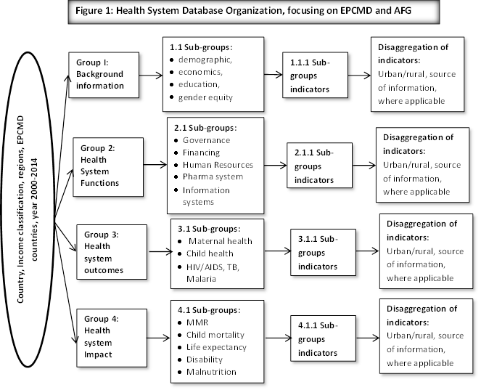
Like starting any analysis, we encourage you to think about what quentions you want to answer through the analysis. Write down those questions so that when you start the analysis, you can select the appropriate tab/options in the tool that would lead you to desired output. However, if you make a mistake, you can always correct it by repeating the analysis.

Comparison of HS Indicators

Introduction

This function allows two types of comparisons over time: a) Comparison of indicators within a given country; b) Comparisons of a single indicator by different countries. Both comparisons are limited to five indicators and five countries to facilitate better visualization of data. Analysis could take multiple forms such as showing possible associations between per capita GDP with child and maternal mortality or gaps in services between antenatal care, skilled birth attendants and postnatal care.
Some of the illustrative analysis questions under this option include:
- Is there a change in nurse/midwifery density over time for countries X, Y and Z?
- Does higher level of total health expenditure associated with lower maternal mortality ratios and increased full immunization coverage for children <1 year?
Click the tab “comparison of HS indicator” to get the following screen for the selection of set of countries.
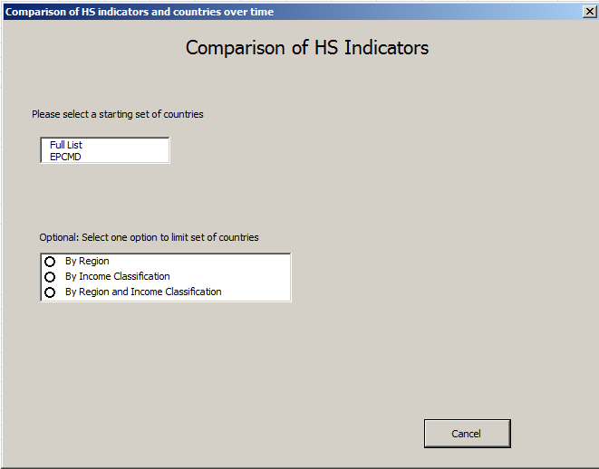
Step 1
Selecting region/income or both when you select EPCMD or full list is optional. It limits country selection by the option selected.
You can select option depending upon your analysis question.
Based on your analysis question, select whether you want to focus on EPCMD countries or select countries from full list. In this example, we selected EPCMD countries.

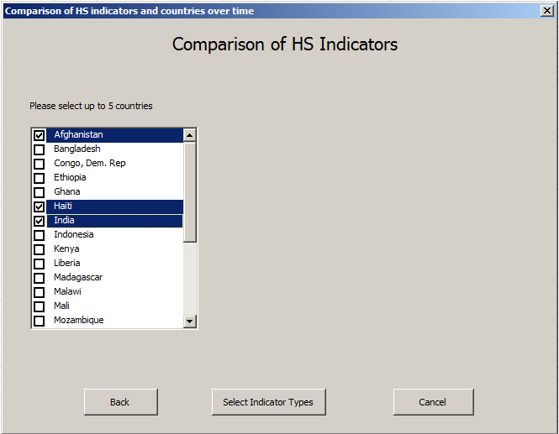
Step 2
Narrow your countries to a maximum of 5.
Note: The tool will not allow you to proceed if you select more than 5 countries. Therefore, always select 5 countries.

Once you have selected your countries click “Select Indicator Type” to proceed.

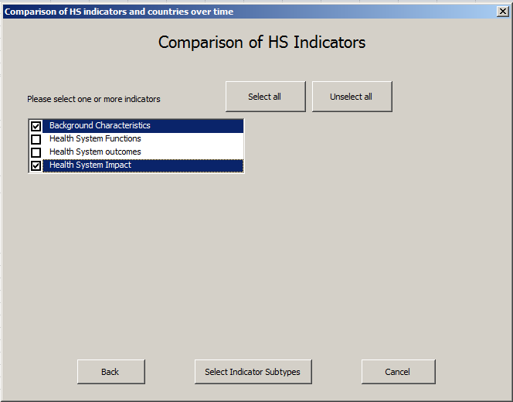
Step 3
Note: This window gives you option to select various groups of indicators. These groups are described in code book (see section 2).
Select your indicators of interest.

Then Click “Select Indicator Subtypes” to proceed.

These tabs allow you to select or unselect all groups of indicators.
Step 3
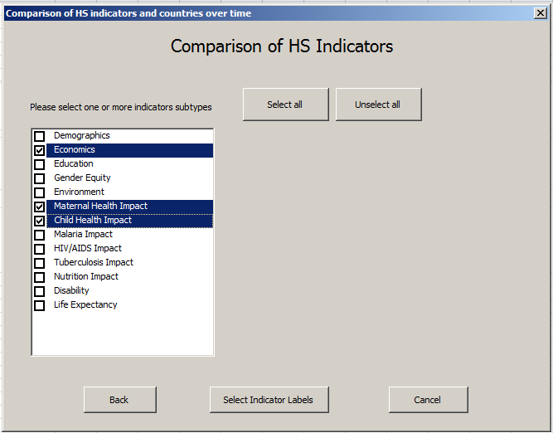
Step 4
Here indicators broken down by subtypes.

Select appropriate categories which reflect indicators relevant to your analysis.

Click “Select Indicator Labels” to proceed.
After indicator selection, click “Select Indicators” to proceed.
Select five or less indicators from this list by clicking the boxes, based on your analysis questions.
The indicator sub-type is broken down into indicator labels. Since we selected the indicator sub-types, we have all the indicators available under these sub-types. However, we can not select more than five indicator labels because comparison is limited to five as, described under introduction
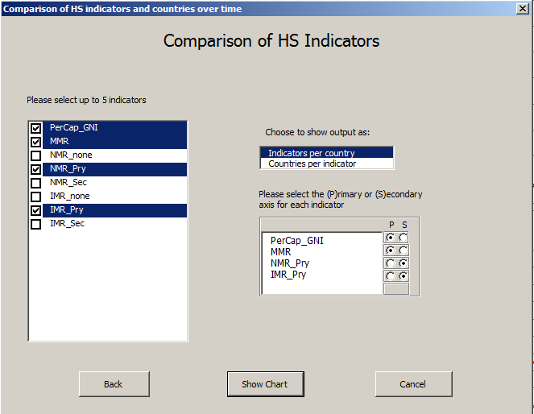
Step 5
Once indicators are selected choose output type – indicators by country ( output of indicator comparison within a country) or countries by indicator (output of countries comparison by indicator).

These indicators come from different sources and at times are disaggregated by source and by urban rural, education. Select up to 5 indicators.

Click “Show Chart” to get the results in new excel sheet.

Some indicators might be described in percentage and others in dollars or per 100,000, Thus, to make the visualization easy, use different axis as primary (P) or secondary axis to display data.

Select labels for the indicators: Select as many labels as you like.

If you have selected “indicators by country” then the following output will appear:

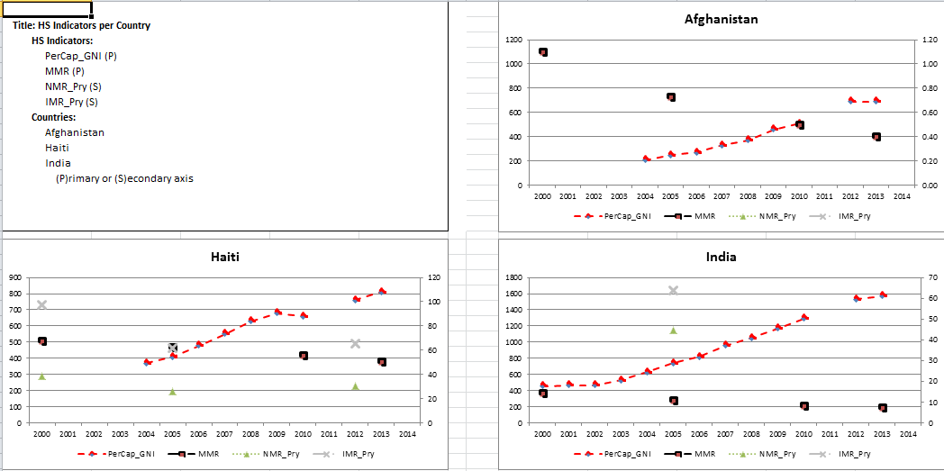
Note: Please note that you can enlarge the charts for better visualization. If needed, you can change chart type as well.
Interpretation: Check you analysis questions and check whether the charts provide the answer. These charts are about indicators values over time within a country. We suggest some simple rules to follow for interpretation:

- First, study each indicator values and see whether a trend exist over time.
- Second, compare indicators and observe whether they are changing together?
- Third, present findings with a qualifier that you need further tests to conclude that the observed associations or trends are statistically significant.
Example: In Haiti, GNI has increased from 370 in 2004 to 810 in 2013. Maternal mortality ratio (per 100,000 live births) has decreased from 470 in 2005 to 380 in 2013, while neonatal mortality rates have slightly increased from 26.2/1000 in 2005 to 30.6/1000 in 2012. There seems to be an association between increased GNI and decrease in maternal mortality. However, same association between increased GNI and lower NMR is not holding. We need further analysis to show whether association between GNI and MMR is statistically significant.

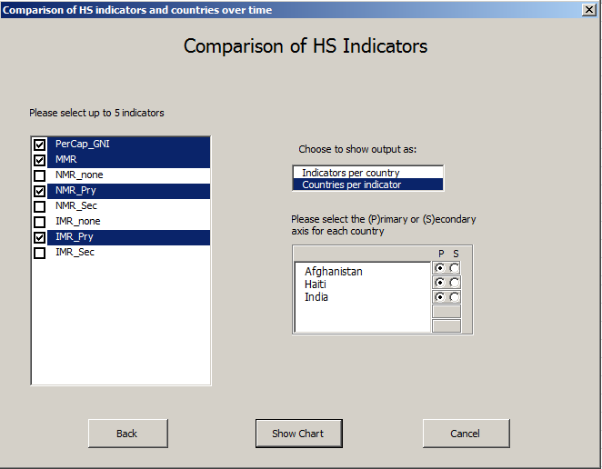
Step 6
Some indicators might be described in percentage and others in dollars or per 100,000. To make the visualization easy, use different axis as primary (P) or secondary axis to display data.

However, you do not need to use different axis here because each indicator is compared against countries.

If you have selected “countries by indicator” then the following output will appear:

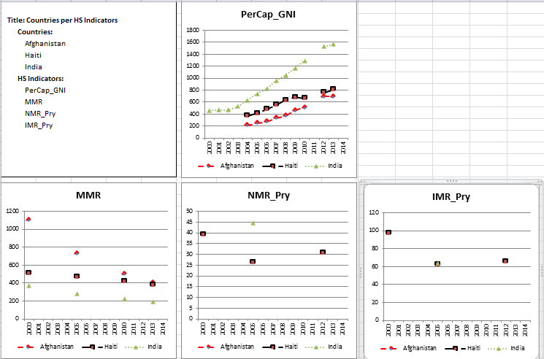
Interpretation: The analysis question is different here. Do countries differ on selected indicator? It is about comparing countries on a specific indicator. We suggest some simple rules to follow for interpretation:
- First, study each country indicator values and see whether a trend exist over time
- Second, compare countries and observe similarities and differences?
- Third, present findings with a qualifier that you need further tests to conclude that the observed associations or trends are statistically significant.

Example: Afghanistan per capita GNI is slowly increasing since 2004 and has threefold increase by 2014 compared to 2004. The same trend could be found for Haiti. However, India’s per capita GNI was stagnant from 2000 to 2004 but started increasing at a faster rate, more than doubling from 2004 to 2013. Afghanistan has the lowest per capita GNI, while India has the highest and Haiti per capita GNI lies closer to Afghanistan.

Benchmarking Countries on HS Indicators

Introduction

Benchmarking is nothing but a comparison using a specified standard. The purpose of benchmarking is continuous improvement by learning from others producing similar outputs but of better quality or at lower cost or both. From a health system perspective, outputs could mean better health system functions, outcomes and impact. Benchmarking could be used for comparing health systems of different countries or health system performance among regions/districts within a given country.
Benchmarking answers the following questions:
- Who is falling below or above the specified standard? For example, specifically, how many are below and above the specified standard?
- Are the majority (define it) of unit of analysis (people, organization, administrative units) below or above a specified standard indicating systemic or special issues?
- What and where improvements are needed by identifying areas below specified level of performance?
Benchmarking answers to these questions to improve performance. Benchmarking standards are usually specified based on the expectation of what is possible, available knowledge from existing national and international literature, historical norms, expert consensus, etc. However, if the standards are not available or not applicable in a country or regional context, then it is better to create standards using the existing data. Mean, median and quartile are commonly used for benchmarking in the absence of specific standard. We have followed the same tradition and provided these options along with option for specifying a certain standard, if one wants to use it.

Some common steps for benchmarking
Allow some variations in standard of comparison: There is consensus that it is not possible to adhere to an absolute standard because no one is perfect and variations exist in people and organizations performance. However, there is a need to limit variation in the standard in either direction to avoid inefficiencies. In addition, variation in standard should be kept at a level to identify low and higher performers as well as to challenge the performer to strive for continuous improvement. Identification of high or lower performers helps to identify the unique characteristics of these performers to develop interventions for further improving performance. Variations in performance standard should be small in order to identify low and higher performing countries and learn from them. In order facilitate this we have provided options to select level of variation in selected standard. The default is +10% variations relative to selected standard. For example, if the standard is 35% and 10% variation is allowed, then variation would be +3.5 (35*.1=3.5) and standard would range from 31.5 to 38.5 (35+3.5). This means the low performing countries would be below 31.5% and high performing countries would be above 38.5%. The benchmarking tool provides an option for a variation value of 2%, 5%, 10%, or your choice. The analysis table will display the specified range or standard without color. Values above or below the selected ranges will be in different colors making it easy to identify which countries are falling below or above the specified range of standard.
Select time range: We have provided an option for selecting all data or specific years for benchmarking. Since missing data exist due to surveys being conducted in intervals at different times or not conducted at all, we encourage you to use all data option for time period. This option provides all available data, but only the latest data will be used during analysis. The drawback of this option is that some data might be recent while other might be 10 year old, thus making comparison limited. To avoid this mismatch of old and latest data, use a range of 5 years interval such as 2000-2005 or 2006-2011.
Select benchmarking options: There are four options for benchmarking. The different benchmarking analysis includes:
- Fixed value option: Benchmarks using a specified standard. You enter the standard and then select a range of specified standard.
- Mean: Used when there is no specified standard. It is based on calculating the mean of indicator from all selected countries indicators. The drawback is that mean is always affected by extreme values. However, it is simple and easy to interpret.
- Median: Is not affected by extreme values. It represents the middle value of indicator of selected countries. Some time, it is difficult to understand or explain it because of its uncommon use.
- Quartile: option helps to understand the spread of the data and identifying countries lying in quartile of 25, 50, 75 and above 75 percentiles .
Some of the illustrative analysis questions could be as follows:
- How many selected countries fall below and above a specified standard range of chosen indicator?
- How many selected countries fall below and above a specified mean range of chosen indicator?
- How many selected countries fall below and above a specified median range of chosen indicator?
- How many selected countries fall below and above a specified quartile of chosen indicator?
- Which selected country has the highest and lowest values of selected indicators?
- How many countries fall within the specified range of standard, mean and median value of indicator?
- Did the selected countries show a consistent pattern of low or high performance in selected indicators?

After clicking the “Benchmaking tab”, the following window appear:
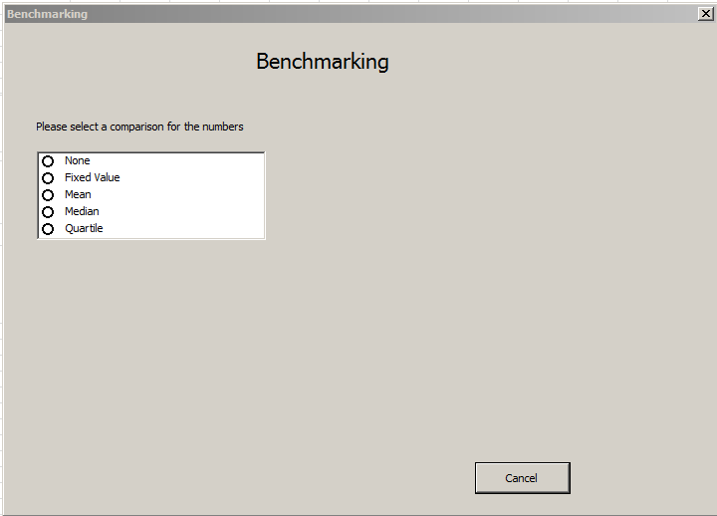
The benchmarking paramenter options are provided here.

“None”: checking availability of data for analysis question. It is not used for benchmarking

“Fixed value”: benchmarking against a known standard

“Mean”: mean of the selected indicators for selected countries are calculated for benchmarking when standard is unknown

“Median” use to avoid the effect of extreme values as the case with mean. It will provide you the 50th percentile value

“Quartile” option provides information on where the indicator values lie in four quartiles.

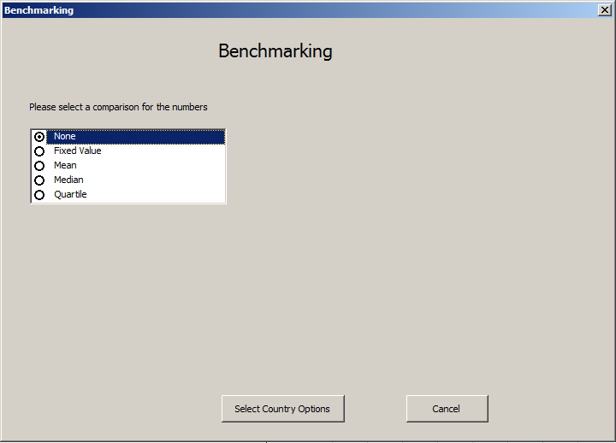
Click to select benchmarking parameter. Then click “Select Country Options” to proceed.
Step 1
Note: Before beginning a benchmarking analysis run the analysis as “None” during Step 1. This option does not conduct any benchmarking, but provides information on the available and missing data for the selected countries and indicators. The missing data is excluded and shows up as empty cell. This allows you to decide whether enough information is available to conduct the benchmarking analysis.

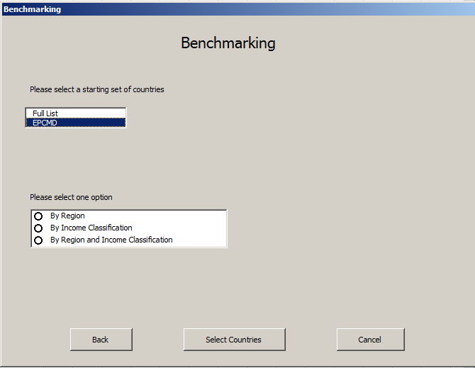
Step 2
Click “Select Countries” to proceed.
Optional: Narrow down search by selecting countries by region, income classification, or by both region and income classification.
Select one option either full country list or EPCMD countries.
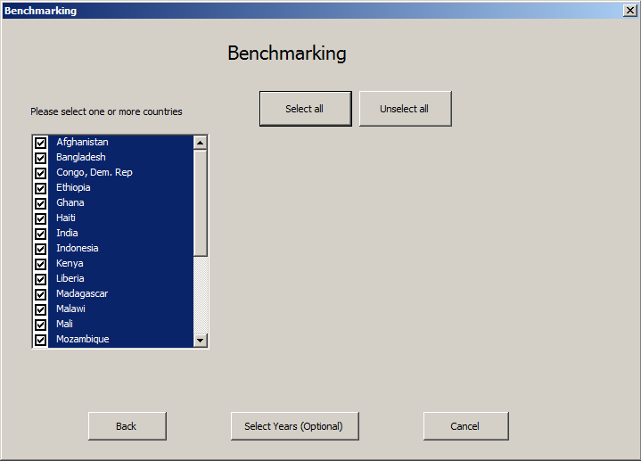
Select at least one country.
Click “Select Years (Optional)” to proceed.
Step 3

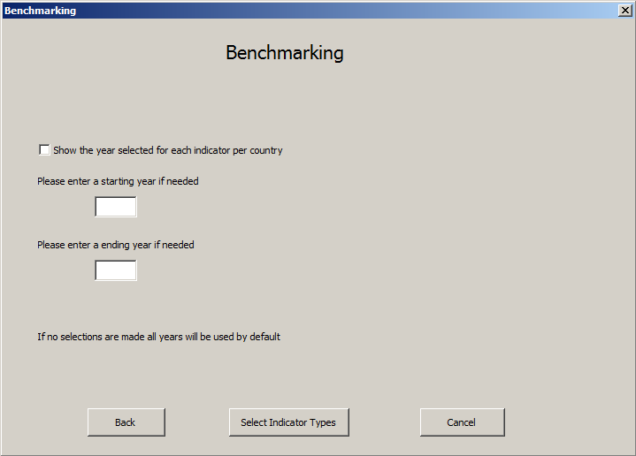
Step 4
Year selection gives you the option to select a range of years to be included for analysis as explained under introduction section.

If you do not select a start and end year then all years from 2000 to 2014 will be used for analysis as default.

We suggest using a five year interval, where possible to assure data availability

Click “Select Indicator Type” to proceed.
The output does not show the specific year, however if you prefer to view the year in the analysis output, then click here.

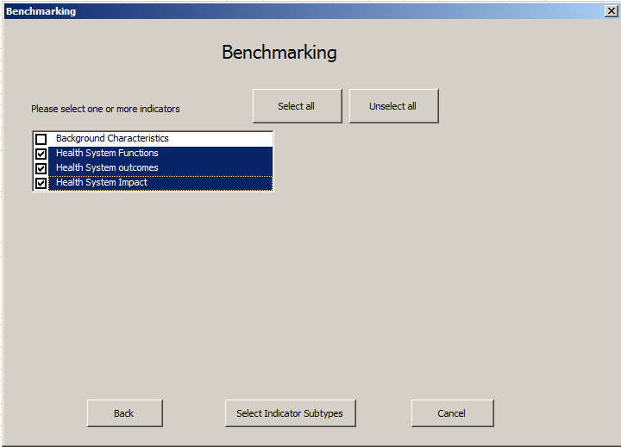
Step 5
Select all groups of indicators by clicking to “select all” or select indicators individually.

However, if you are selecting few groups of indicator based on your analysis question then selects them by clicking the adjoining boxes. It will highlighted the selected group as shown

Click “Select Indicator Subtypes” to proceed.
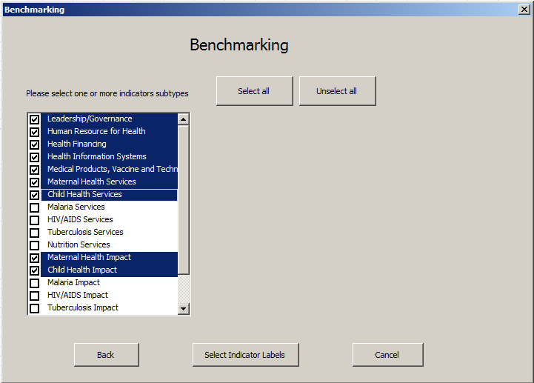
Step 6
Select at least one indicator subtype.

Choose indicator(s) based on your analysis questions by clicking the boxes

Click “Select Indicator Labels” to procced.
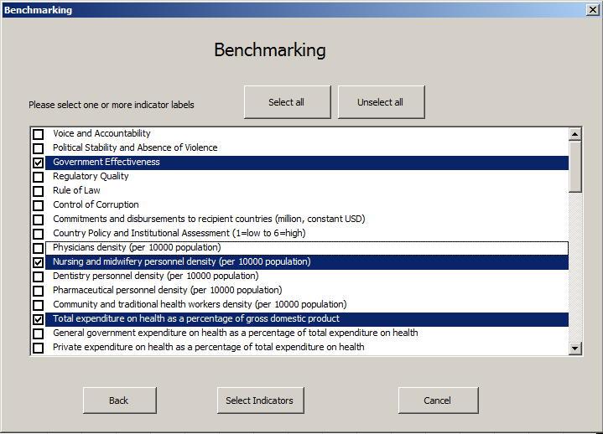
Step 7
Select the indicator labels you are interested. The indicator labels available are limited from your previous selections.
When finished click “Select Indicator”.
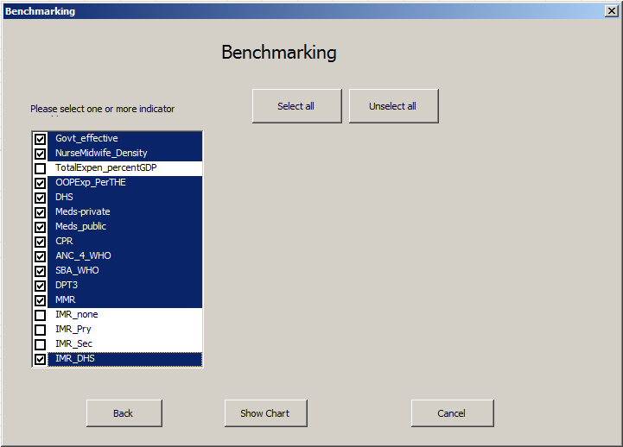
Finally, Click on “indicators boxes” from the disaggregated list of indicators, based on your analysis question.
When finished click “Show Chart” to view results.
Step 8

Since no benchmarking parameter was selected for this example, the table (see next page) only displays EPCMD countries by selected indicators information. As pointed out earlier, the best use of the table without set benchmarking parameters is to explore which variable has the most missing data, and to make a decision whether the variables with missing data should be included for benchmarking. The table showed many countries do not have information on variables related to availability of generic medicine in public and private sectors while countries are not missing data on indicators such as government effectiveness and out-of-pocket expenditures.

Take home Messages
- Use “none” option to understand level of missing data in selected countries and indicators
- Determine whether enough information is available to conduct benchmarking
All years reviewed from 2000 to 2014
Country | Govt_  effectiveness |  | NurseMid  wife_Density | OOPExp  _PerTHE | DHS | Generic_meds  _avail_private | Generic_meds  _avail_public | Contracep  _prev | ANC_4  _WHO | DPT3 | MMR | IMR_  DHS
Afghanistan |  | -1.43 | 5.00 | 74.40 |  |  |  | 21.20 | 9.90 |  | 400.00
Bangladesh |  | -0.82 | 2.18 | 63.40 | 1.00 |  |  | 61.20 | 24.70 | 92.30 | 170.00 | 50.00
Congo, D Rep |  | -1.59 |  | 25.10 | 1.00 | 65.40 | 55.60 | 17.70 | 48.00 | 60.40 | 730.00 | 65.00
Ethiopia |  | -0.52 | 2.53 | 41.20 | 1.00 |  |  | 28.60 | 19.10 | 31.40 | 420.00 | 74.00
Ghana |  | -0.09 | 9.26 | 28.70 | 1.00 | 44.60 | 17.90 | 19.50 | 86.60 | 79.80 | 380.00 | 54.00
Haiti |  | -1.53 |  | 3.50 | 1.00 | 54.30 | 17.60 | 34.50 | 67.30 | 52.30 | 380.00 | 64.00
India |  | -0.19 | 17.11 | 57.60 |  | 76.80 | 22.10 | 54.80 | 72.00 | 49.40 | 190.00 | 65.00
Indonesia |  | -0.24 | 13.83 | 45.40 | 1.00 | 57.80 | 65.50 | 61.90 | 87.80 | 68.30 | 190.00 | 34.00
Kenya |  | -0.49 | 7.92 | 47.60 | 1.00 | 72.40 | 37.70 | 45.50 | 47.10 | 81.20 | 400.00 | 59.00
Liberia |  | -1.33 | 2.74 | 21.20 | 1.00 |  |  | 20.20 | 78.10 | 61.50 | 640.00 | 69.00
Madagascar |  | -1.12 | 3.16 | 31.50 |  |  |  | 39.90 | 51.10 | 71.40 | 440.00 | 53.00
Malawi |  | -0.56 | 3.43 | 12.60 | 1.00 |  |  | 46.10 | 45.50 | 87.30 | 510.00 | 73.00
Mali |  | -0.84 | 4.30 | 60.70 | 1.00 | 70.00 | 81.00 | 10.30 | 41.20 | 51.40 | 550.00
Mozambique |  | -0.65 | 4.12 | 5.00 | 1.00 |  |  | 11.60 | 50.60 | 70.60 | 480.00 | 71.00
Nepal |  | -0.93 | 4.60 | 49.20 | 1.00 |  |  | 49.70 | 50.10 | 91.10 | 190.00 | 53.00
Nigeria |  | -1.01 | 16.05 | 65.90 |  |  |  | 15.10 | 51.10 |  | 560.00
Pakistan |  | -0.80 | 5.73 | 54.80 |  |  |  | 35.40 | 36.60 |  | 170.00
Rwanda |  | 0.00 | 6.89 | 21.10 | 1.00 |  |  | 51.60 | 35.40 | 95.80 | 320.00 | 61.00
Senegal |  | -0.48 | 4.20 | 34.10 | 1.00 |  |  | 17.80 | 46.50 | 76.80 | 320.00 | 53.00
South Sudan |  | -1.49 |  | 56.70 |  |  |  | 4.00 | 17.00 |  | 730.00
Tanzania |  | -0.67 |  | 31.80 | 1.00 | 47.90 | 23.40 | 34.40 | 42.80 | 84.80 | 410.00 | 60.00
Uganda |  | -0.58 | 13.06 | 49.30 | 1.00 | 80.00 | 20.00 | 30.00 | 47.60 | 66.00 | 360.00 | 65.00
Yemen, Rep. |  | -1.20 | 6.77 | 71.70 |  |  |  | 27.70 | 28.20 |  | 270.00
Zambia |  | -0.48 | 7.84 | 23.90 | 1.00 |  |  | 40.80 | 60.30 | 82.20 | 280.00 | 48.00

Benchmarking using fixed value
Most of the time, the benchmarking value is fixed using historical or normative data, experts consensus or international standard. In order to complete an analysis with this standard first click “fixed value” from the comparison for the numbers box, as seen in Step 1 below. Please note that since benchmarking is using a fixed value for a particular indicator, only that indicator should be selected. The fixed value option for benchmarking should not be used for multiple indicators because the fixed value standard could be different for different indicators.
Once you have selected “fixed value” you will be prompted to enter this value. We have assumed that every indicator has some variability either due to margin of error of survey or variation in country health system performance. Variability is accounted for by allowing the user to set upper and lower control limits of variability. This variability could be based on the historical norms to identify the best and worst performers lying above or below the upper and lower limits of the variability allowed. Thus, the third step is to select a variation range starting with 2%, 5%, 10%, or more.
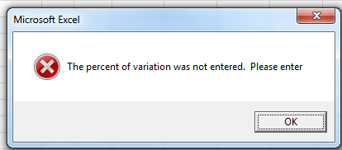
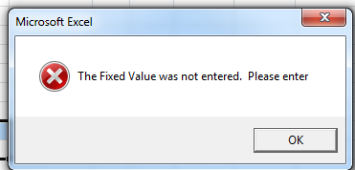
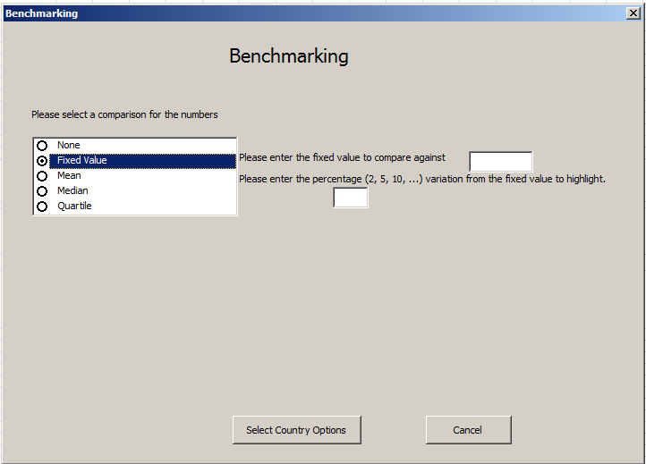
Step 1
If you click “select countries”, without entering fixed variation values and then the following message will appear.
If you do not enter fixed value and click “select countries” then the following message will appear.

Step 1c: select a value to allow variation that identifies the best and worst performers.
Step 1b: select a fixed value based on historical norms or other standards.
Step 1a: Click fixed value option for benchmarking .knowledge

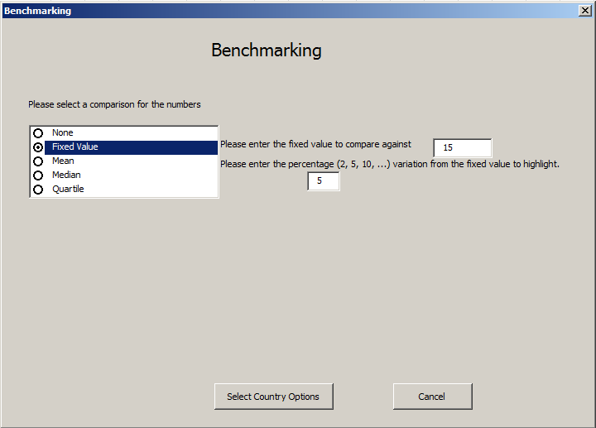
Step 2
See Steps 3 and 4 on page 27 (benchmarking of countries) for a refresher on how to select countries and year range for analysis. Therefore, we have not repeated those steps here to save space.

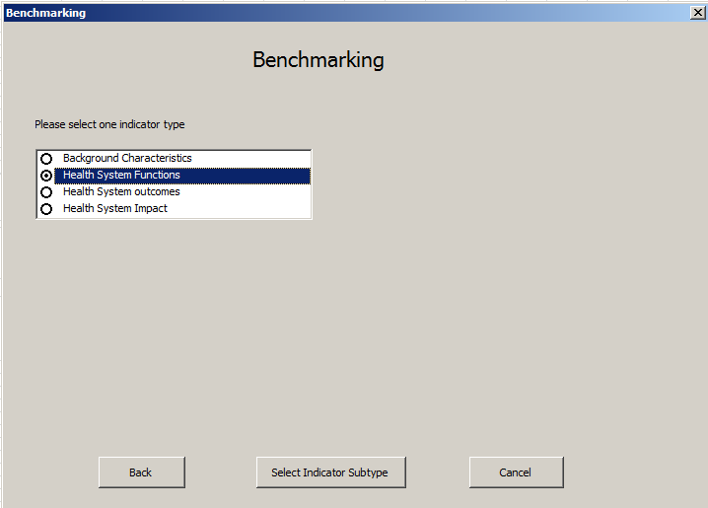
Click on the group, where the indicator is located based on your analysis questions.
Click “Select Indicator subtype” to proceed.

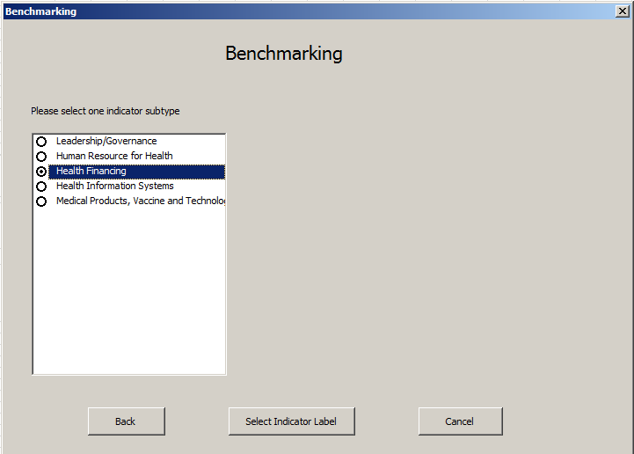
A list of indicator subtypes for the indicator type selected will be displayed. Select 1 indicator subtype to analyze.
Click on “Select Indicator Label” to proceed.
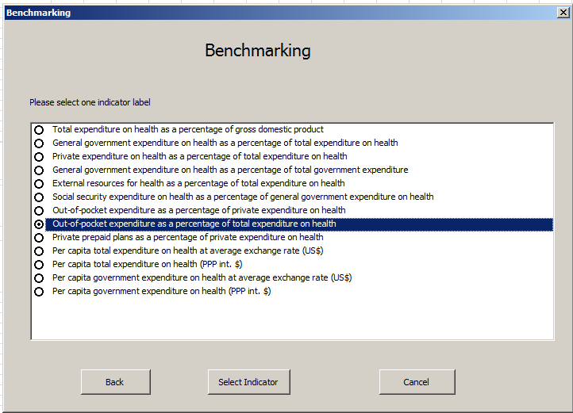
Select the indicator label based on your analysis.
Click “Select Indicator” to proceed.

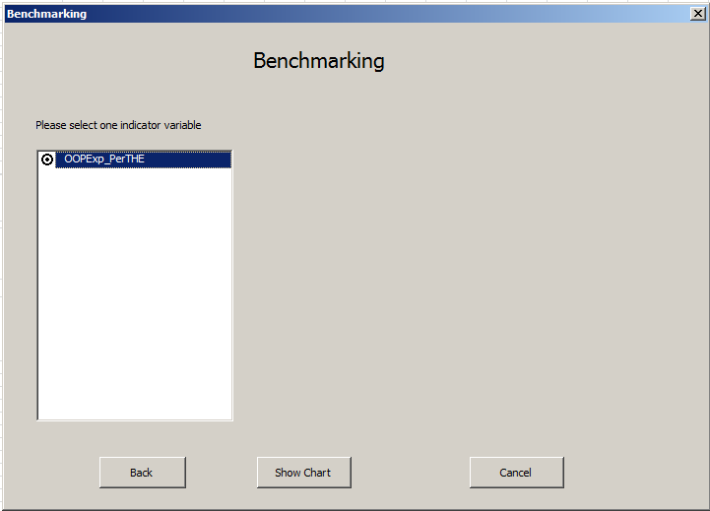
If the indicator is disaggregated, then the tool will only allow the selection of one indicator. However, if the indicator is not disaggregated, as in the example, then you can select the only option available.
Click on “Show chart” to proceed.
The table showing the analysis results will appear (see next page). Please note that since we have not selected a range of years, the default, all years from 2000 to 2014, was selected. However, the data displayed is from the most recent year. To display the year, select the year display option during step 4 (see page 27, benchmarking of countries).
Our Example Analysis Question: Which EPCMD countries were within fix value control limits (+5 of mean) or above and below the upper and lower control limits for out-of-pocket health expenditure?
Percentage variation is not absolute but rather relative to fixed value. In this case, the fixed value is 15. Thus, 5% of the fixed value of 15 is .75 (.05*15=.75). This means the lower limit of 15 would be 14.25 and upper limit would be 15.75. We observe that all of the countries have out-of-pocket health expenditure more than 15.75% except three countries Haiti, Malawi and Mozambique, which have lower out of pocket health expenditure. This analysis raises the question of why these three countries, despite being poor have low out of pocket expenditure. This also raises the question “who is paying for their health expenditure- government or donors?” The analysis also showed that most EPCMD countries need some financial protection scheme to reduce out of pocket expenditure. Please note that the variation is too small to differentiate countries. However, if the fixed value is used as a cut point, then selecting small variation would be good to keep the range value close to the cut point.

Take home message:
- Use your discretion based on the analysis question to select fixed value and its variation values.
- Fixed value should only be used if you know the fixed value from historical data to benchmark from.
- Fixed value is good for use when you want to have control over the change.
All years reviewed from 2000 to 2014
Country | OOPExp_PerTHE
Afghanistan | 74.40
Bangladesh | 63.40
Congo, Dem. Rep | 25.10
Ethiopia | 41.20
Ghana | 28.70
Haiti | 3.50
India | 57.60
Indonesia | 45.40
Kenya | 47.60
Liberia | 21.20
Madagascar | 31.50
Malawi | 12.60
Mali | 60.70
Mozambique | 5.00
Nepal | 49.20
Nigeria | 65.90
Pakistan | 54.80
Rwanda | 21.10
Senegal | 34.10
South Sudan | 56.70
Tanzania | 31.80
Uganda | 49.30
Yemen, Rep. | 71.70
Zambia | 23.90
Fixed Value | 15
Min | 3.50
Max | 74.40
Legend
Fixed Value | +5% or above | Within +/-5% | -5% or below
Missing data is blank
Light Blue color shows the value 5% or more above the fixed value
Dark color shows the value 5% or lower below the fixed value

No color shows the value within +5% of the fixed value

Benchmarking using mean
When there is not a fixed value available for comparison, then the mean of the selected group countries is a good choice for comparing them. The analysis question could be whether selected countries fall below or above the mean. Again, the tool accounts for variation in the mean with an option provided to select a range of variation from +2%, 5%, 10%, or more to identify the best and worst performers. As indicated in section on fixed value, the narrow and wider control limits are not good for differentiating best and worst performers, unless the narrow and wide variations are the norms and should be selected. Thus, allow variation based on expert opinion or expectation of variation in that process. Mean is affected by extreme values. This limitation should be kept in mind when interpreting the analysis findings.
Since the mean of the indicator is calculated based the selected group of countries, it is possible to benchmark multiple indicators simultaneously, unlike when completing the fixed value benchmarking analysis.

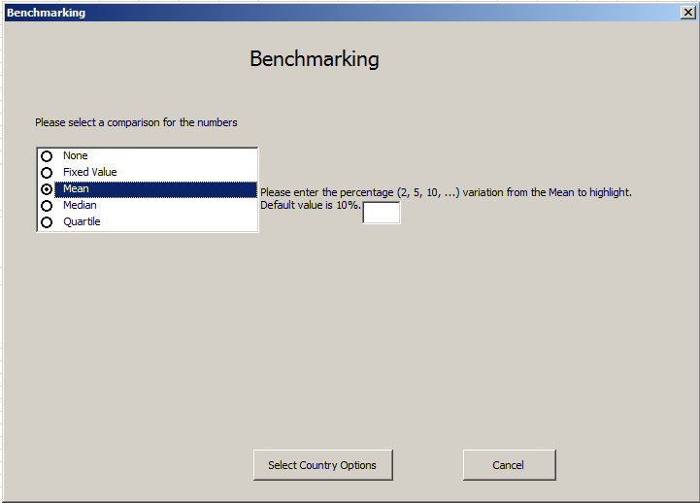
Click mean to select the mean for benchmarking.
Enter the “percentage of variation” around the mean which is acceptable. If you do not select a value then default value of +10% will be used during analysis.
Click on the “Select Countries” to proceed.
Step 1

See Steps 2-4 on page 27 (section - benchmarking of countries) for a refresher on how to select countries and year range for analysis. We have not repeated those steps here to save space.

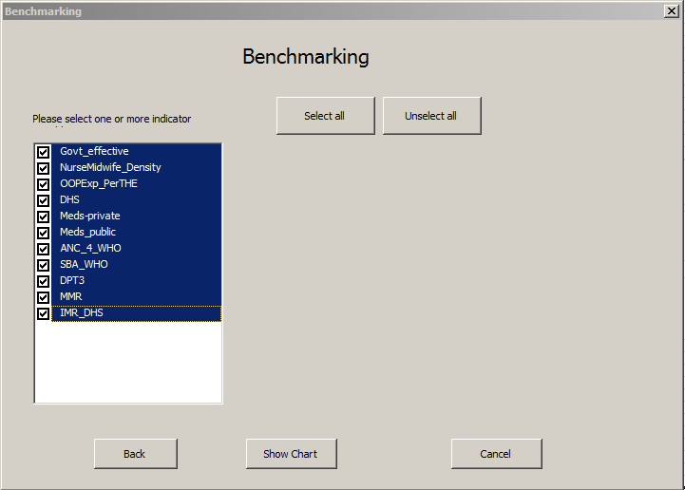
This is the last indicator selection option where indicators are displayed by their disaggregation. You can see that IMR data is disaggregated by source of information, while generic medicines data is disaggregated by public and private sector.
Select one or more indicators based on your analysis question for benchmarking.
Click on “Show Chart” to get the analysis table.
Step 5
The table showing analysis results will appear (see next page). Please note that year was not selected therefore the default, all years from 2000 to 2014, was used; however, the data displayed is from the most recent year but is not displayed in table. To display year, select the year display option during step 4 (section - comparison of countries).
The example analysis question was, “Which EPCMD countries were within mean control limits (+10% of mean)? Which countries were above and below the upper and lower control limits of mean?”

Percentage variation is relative to the group mean of the selected indicator(s), therefore it cannot be calculated until the mean is determined. The range of variation of +10% of the mean is reflected by no color in the column of the indicator. Values above the upper limit of the mean are displayed by a light blue color while values below the lower limit of the mean are displayed by dark color.

Note: It is very important to interpret the value carefully. The indicator with a higher value usually indicates a better situation. However, that should not be taken as a rule. Each indicator value should be interpreted based on its meaning. For example, higher negative values for government effectiveness indicate worse situations than lower negative values. This can also be said about other variables such as infant and maternal mortality.

To understand the analysis table interpret each indicator by identifying which countries fall within the variation mean range and which indicators fall above and below the upper and lower limits of a particular indicator. For example, the mean out of pocket expenditure for EPCMD countries is 40%, indicating that on average the people in EPCMD countries spend 40% of their health expenditures from their pocket. Ethiopia falls in that mean range, however, half of the countries are above or below the upper and lower limits of group mean. You can interpret the findings similarly for other indicators.

Second, the Table provides the opportunity to examine countries across the various selected variables and identify which countries are consistently below the lower limit of selected indicators and which countries are above the upper limit indicating higher or lower performance, given that value and its color coding are interpreted correctly. The table shows that anomaly, as explained earlier, of the higher values of infant and maternal mortality represented in light blue, even though the situation is worse, while other indicators in light blue are actually good. Keeping this discrepancy in mind, we observe that Afghanistan, Ethiopia and Yemen are worst performers for these health system performance indicators among EPCMD countries, while Indonesia and India are the best performers.

Take home message:
- Use your discretion to select whether mean is the best option for analysis based on analysis question.
- Mean is a good option when you do not have historical information for benchmarking.
- Assure the meaning of value to interpret it correctly. High number are not always good.
- First, interpret each selected indicator by country.
- Second, assess best and worst performing countries comparing across the selected indicators.
- Can analyze more than 1 indicator at a time.

All years reviewed from 2000 to 2014
Country |  | Govt_  effectiveness |  | NurseMidwife  _Density |  | OOPExp  _PerTHE |  | DHS | Generic_meds  _avail_private |  |  | Generic_meds  _avail_public |  |  |  | Contracep  _prev |  | ANC_4  _WHO |  |  | SBA_  WHO |  |  | Vacc  _DHS |  |  |  | MMR |  |  | IMR  _Pry
Afghanistan |  | -1.43 |  | 5.00 |  | 74.40 |  |  |  |  |  |  |  |  |  | 21.20 |  | 9.90 |  |  | 36.30 |  |  |  |  |  |  | 400.00
Bangladesh |  | -0.82 |  | 2.18 |  | 63.40 |  | 1.00 |  |  |  |  |  |  |  | 61.20 |  | 24.70 |  |  | 43.50 |  |  | 86.00 |  |  |  | 170.00 |  |  | 50.60
Congo, DR |  | -1.59 |  |  |  | 25.10 |  | 1.00 | 65.40 |  |  | 55.60 |  |  |  | 17.70 |  | 48.00 |  |  | 80.10 |  |  | 45.30 |  |  |  | 730.00 |  |  | 67.30
Ethiopia |  | -0.52 |  | 2.53 |  | 41.20 |  | 1.00 |  |  |  |  |  |  |  | 28.60 |  | 19.10 |  |  | 10.00 |  |  | 24.30 |  |  |  | 420.00 |  |  | 58.10
Ghana |  | -0.09 |  | 9.26 |  | 28.70 |  | 1.00 | 44.60 |  |  | 17.90 |  |  |  | 19.50 |  | 86.60 |  |  | 67.20 |  |  | 79.00 |  |  |  | 380.00 |  |  | 54.80
Haiti |  | -1.53 |  |  |  | 3.50 |  | 1.00 | 54.30 |  |  | 17.60 |  |  |  | 34.50 |  | 67.30 |  |  | 37.30 |  |  | 45.20 |  |  |  | 380.00 |  |  | 65.60
India |  | -0.19 |  | 17.11 |  | 57.60 |  |  | 76.80 |  |  | 22.10 |  |  |  | 54.80 |  | 72.00 |  |  | 66.60 |  |  | 43.50 |  |  |  | 190.00 |  |  | 63.80
Indonesia |  | -0.24 |  | 13.83 |  | 45.40 |  | 1.00 | 57.80 |  |  | 65.50 |  |  |  | 61.90 |  | 87.80 |  |  | 83.10 |  |  | 65.60 |  |  |  | 190.00 |  |  | 47.70
Kenya |  | -0.49 |  | 7.92 |  | 47.60 |  | 1.00 | 72.40 |  |  | 37.70 |  |  |  | 45.50 |  | 47.10 |  |  | 43.80 |  |  | 68.30 |  |  |  | 400.00 |  |  | 63.40
Liberia |  | -1.33 |  | 2.74 |  | 21.20 |  | 1.00 |  |  |  |  |  |  |  | 20.20 |  | 78.10 |  |  | 61.10 |  |  | 54.80 |  |  |  | 640.00 |  |  | 66.90
Madagascar |  | -1.12 |  | 3.16 |  | 31.50 |  |  |  |  |  |  |  |  |  | 39.90 |  | 51.10 |  |  | 44.30 |  |  | 61.60 |  |  |  | 440.00 |  |  | 55.80
Malawi |  | -0.56 |  | 3.43 |  | 12.60 |  | 1.00 |  |  |  |  |  |  |  | 46.10 |  | 45.50 |  |  | 87.40 |  |  | 80.90 |  |  |  | 510.00 |  |  | 75.30
Mali |  | -0.84 |  | 4.30 |  | 60.70 |  | 1.00 | 70.00 |  |  | 81.00 |  |  |  | 10.30 |  | 41.20 |  |  | 57.10 |  |  |  |  |  |  | 550.00 |  |  | 79.60
Mozambique |  | -0.65 |  | 4.12 |  | 5.00 |  | 1.00 |  |  |  |  |  |  |  | 11.60 |  | 50.60 |  |  | 54.30 |  |  | 64.10 |  |  |  | 480.00 |  |  | 74.50
Nepal |  | -0.93 |  | 4.60 |  | 49.20 |  | 1.00 |  |  |  |  |  |  |  | 49.70 |  | 50.10 |  |  | 36.00 |  |  | 87.00 |  |  |  | 190.00 |  |  | 52.50
Nigeria |  | -1.01 |  | 16.05 |  | 65.90 |  |  |  |  |  |  |  |  |  | 15.10 |  | 51.10 |  |  | 35.20 |  |  |  |  |  |  | 560.00
Pakistan |  | -0.80 |  | 5.73 |  | 54.80 |  |  |  |  |  |  |  |  |  | 35.40 |  | 36.60 |  |  | 52.10 |  |  |  |  |  |  | 170.00
Rwanda |  | 0.00 |  | 6.89 |  | 21.10 |  | 1.00 |  |  |  |  |  |  |  | 51.60 |  | 35.40 |  |  | 69.00 |  |  | 90.10 |  |  |  | 320.00 |  |  | 58.10
Senegal |  | -0.48 |  | 4.20 |  | 34.10 |  | 1.00 |  |  |  |  |  |  |  | 17.80 |  | 46.50 |  |  | 50.50 |  |  | 62.80 |  |  |  | 320.00 |  |  | 39.90
South Sudan |  | -1.49 |  |  |  | 56.70 |  |  |  |  |  |  |  |  |  | 4.00 |  | 17.00 |  |  | 17.20 |  |  |  |  |  |  | 730.00
Tanzania |  | -0.67 |  |  |  | 31.80 |  | 1.00 | 47.90 |  |  | 23.40 |  |  |  | 34.40 |  | 42.80 |  |  | 48.90 |  |  | 75.20 |  |  |  | 410.00 |  |  | 59.10
Uganda |  | -0.58 |  | 13.06 |  | 49.30 |  | 1.00 | 80.00 |  |  | 20.00 |  |  |  | 30.00 |  | 47.60 |  |  | 58.00 |  |  | 51.60 |  |  |  | 360.00 |  |  | 62.30
Yemen, Rep. |  | -1.20 |  | 6.77 |  | 71.70 |  |  |  |  |  |  |  |  |  | 27.70 |  | 28.20 |  |  | 44.70 |  |  |  |  |  |  | 270.00
Zambia |  | -0.48 |  | 7.84 |  | 23.90 |  | 1.00 |  |  |  |  |  |  |  | 40.80 |  | 60.30 |  |  | 64.20 |  |  | 68.30 |  |  |  | 280.00 |  |  | 84.00
Mean |  | -0.79 |  | 7.04 |  | 40.68 |  | 1.00 | 63.24 |  |  | 37.87 |  |  |  | 32.48 |  | 47.69 |  |  | 52.00 |  |  | 64.09 |  |  |  | 395.42 |  |  | 62.07
Min |  | -1.59 |  | 2.18 |  | 3.50 |  | 1.00 | 44.60 |  |  | 17.60 |  |  |  | 4.00 |  | 9.90 |  |  | 10.00 |  |  | 24.30 |  |  |  | 170.00 |  |  | 39.90
Max |  | 0.00 |  | 17.11 |  | 74.40 |  | 1.00 | 80.00 |  |  | 81.00 |  |  |  | 61.90 |  | 87.80 |  |  | 87.40 |  |  | 90.10 |  |  |  | 730.00 |  |  | 84.00
 | Legend
 | Mean |  | +10% or above |  | Within +/-10% |  | -10% or below |  |  | Default % values used
Missing data is blank
Light Blue color shows the value 10% or more above the mean
Dark color shows the value 10% or lower below the mean

No color shows the value within +10% of the mean

Benchmarking using median

Mean is affected by extreme values, while median is not, therefore, median is preferable when you find extreme values in the data. For some people median is not intuitive and can be difficult to interpret. The median divides the group of data values equally into two halves using the 50th percentile as the cut off. It is interpreted as half of a group is above x while half the group is below x. Like variations in mean, the tool accounts for variation in median. An option is provided to select a range of variation from 2%, 5%, 10%, or more to identify best and worst performers. However, if you do not select a variation, the default variation is +10%and data will be displayed accounting for that variation. As indicated in section on fixed value, the narrow and wider control limits are not good for differentiating best and worst performers, unless the narrow and wide variations are the norms and should be selected. Thus, allow variation based on expert opinion or expectation of variation in that process.
Since the median of the indicator is calculated based the selected group of countries, it is possible to benchmark multiple indicators simultaneously, unlike the fixed value where only one indicator could be benchmarked.

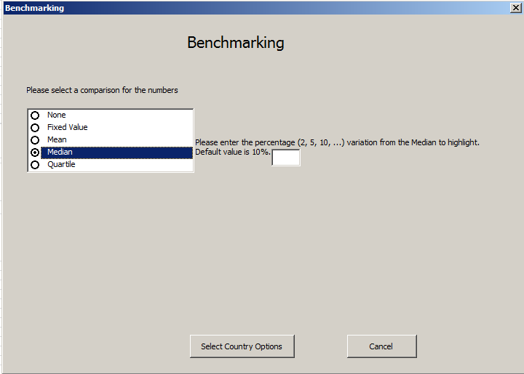
Select median as the comparison for benchmarking.
Enter the “percentage of variation” around the median. If you do not select a value then default value of +10% will be used.
Click on the “Select Countries” to proceed.
See Steps 2-4 on page 27 (section - benchmarking of countries) for a refresher on how to select countries and year range for analysis. We have not repeated those steps here to save space.
The table showing analysis results will appear (see next page). Please note that since a year range was not selected the default, 2000 to 2014, was selected. However, the data displayed is from the most recent year. To display year in the analysis table, select display during Step 4.
The analysis question was, “which EPCMD countries were within median control limits (+10% of median) or above and below the upper and lower control limits?” Percentage variation is not absolute, but rather it is relative to the median of the selected indicator(s) calculated during analysis. The range of variation of + 10% of the median would be reflected by no color in the column of the indicator. However, value above the upper limit of the median would be displayed by light blue color, while countries below the lower limit will be a dark color.

Note: Although the indicator with a higher value usually indicates better situation this should not be taken as a rule. Each indicator value should be interpreted based on its meaning. For example, higher negative values for government effectiveness indicate a worse situation than lower negative values. Same could be said about other values such as infant and maternal mortality. It is very important to interpret the value carefully. It is difficult to reverse color codes when multiple indicators are selected whose values could have opposite meaning.

To understand the analysis Table (see next page) interpret each indicator by identifying which countries fall within variation median range and which countries are above and below the upper and lower limits for a particular indicator. For example, the median out of pocket expenditure for EPCMD countries is 43%, indicating that 50% or more people in EPCMD countries spend 43% of their health expenditures from their pocket and Ethiopia, Indonesia and Kenya falls in that median range. However, half of the countries are above or below the upper and lower limits of group median. You can interpret the findings similarly for other indicators.

Second, the Table provides the opportunity to examine countries across the various selected variables and identify which countries are consistently below the lower limit of selected indicators and which countries are above the upper limit indicating higher or lower performance, given that value and its color coding are interpreted correctly. The table shows that anomaly as explained earlier of the higher values of infant and maternal mortality, which shows light blue color but the situation worse while that is not true for other indicators where the higher value indicates good situation. Keeping this discrepancy in mind, we observe that Afghanistan, Ethiopia, South Sudan and Yemen have worst health system performance indicators among EPCMD countries, while Indonesia and India are the best performers.

Take home message:
- Use your discretion to select whether median is the best option for analysis based on analysis question.
- Median is good option when there are extreme values.
- First, interpret each selected indicator by countries.
- Second, assess best and worst performing countries comparing across the selected indicators.

All years reviewed from 2000 to 2014
Country |  | Govt_  effectiveness |  | NurseMid  wife_Density |  |  | OOPExp  _PerTHE |  | Generic_meds  _avail_private |  | Generic_meds  _avail_public |  | Contracep  _prev |  |  |  | ANC4  _WHO |  | SBA  _WHO |  | Vacc  _DHS |  | MMR |  | IMR  _Pry
Afghanistan |  | -1.43 |  | 5.00 |  |  | 74.40 |  |  |  |  |  | 21.20 |  |  |  | 9.90 |  | 36.30 |  |  |  | 400.00
Bangladesh |  | -0.82 |  | 2.18 |  |  | 63.40 |  |  |  |  |  | 61.20 |  |  |  | 24.70 |  | 43.50 |  | 86.00 |  | 170.00 |  | 50.60
Congo, DR |  | -1.59 |  |  |  |  | 25.10 |  | 65.40 |  | 55.60 |  | 17.70 |  |  |  | 48.00 |  | 80.10 |  | 45.30 |  | 730.00 |  | 67.30
Ethiopia |  | -0.52 |  | 2.53 |  |  | 41.20 |  |  |  |  |  | 28.60 |  |  |  | 19.10 |  | 10.00 |  | 24.30 |  | 420.00 |  | 58.10
Ghana |  | -0.09 |  | 9.26 |  |  | 28.70 |  | 44.60 |  | 17.90 |  | 19.50 |  |  |  | 86.60 |  | 67.20 |  | 79.00 |  | 380.00 |  | 54.80
Haiti |  | -1.53 |  |  |  |  | 3.50 |  | 54.30 |  | 17.60 |  | 34.50 |  |  |  | 67.30 |  | 37.30 |  | 45.20 |  | 380.00 |  | 65.60
India |  | -0.19 |  | 17.11 |  |  | 57.60 |  | 76.80 |  | 22.10 |  | 54.80 |  |  |  | 72.00 |  | 66.60 |  | 43.50 |  | 190.00 |  | 63.80
Indonesia |  | -0.24 |  | 13.83 |  |  | 45.40 |  | 57.80 |  | 65.50 |  | 61.90 |  |  |  | 87.80 |  | 83.10 |  | 65.60 |  | 190.00 |  | 47.70
Kenya |  | -0.49 |  | 7.92 |  |  | 47.60 |  | 72.40 |  | 37.70 |  | 45.50 |  |  |  | 47.10 |  | 43.80 |  | 68.30 |  | 400.00 |  | 63.40
Liberia |  | -1.33 |  | 2.74 |  |  | 21.20 |  |  |  |  |  | 20.20 |  |  |  | 78.10 |  | 61.10 |  | 54.80 |  | 640.00 |  | 66.90
Madagascar |  | -1.12 |  | 3.16 |  |  | 31.50 |  |  |  |  |  | 39.90 |  |  |  | 51.10 |  | 44.30 |  | 61.60 |  | 440.00 |  | 55.80
Malawi |  | -0.56 |  | 3.43 |  |  | 12.60 |  |  |  |  |  | 46.10 |  |  |  | 45.50 |  | 87.40 |  | 80.90 |  | 510.00 |  | 75.30
Mali |  | -0.84 |  | 4.30 |  |  | 60.70 |  | 70.00 |  | 81.00 |  | 10.30 |  |  |  | 41.20 |  | 57.10 |  |  |  | 550.00 |  | 79.60
Mozambique |  | -0.65 |  | 4.12 |  |  | 5.00 |  |  |  |  |  | 11.60 |  |  |  | 50.60 |  | 54.30 |  | 64.10 |  | 480.00 |  | 74.50
Nepal |  | -0.93 |  | 4.60 |  |  | 49.20 |  |  |  |  |  | 49.70 |  |  |  | 50.10 |  | 36.00 |  | 87.00 |  | 190.00 |  | 52.50
Nigeria |  | -1.01 |  | 16.05 |  |  | 65.90 |  |  |  |  |  | 15.10 |  |  |  | 51.10 |  | 35.20 |  |  |  | 560.00
Pakistan |  | -0.80 |  | 5.73 |  |  | 54.80 |  |  |  |  |  | 35.40 |  |  |  | 36.60 |  | 52.10 |  |  |  | 170.00
Rwanda |  | 0.00 |  | 6.89 |  |  | 21.10 |  |  |  |  |  | 51.60 |  |  |  | 35.40 |  | 69.00 |  | 90.10 |  | 320.00 |  | 58.10
Senegal |  | -0.48 |  | 4.20 |  |  | 34.10 |  |  |  |  |  | 17.80 |  |  |  | 46.50 |  | 50.50 |  | 62.80 |  | 320.00 |  | 39.90
South Sudan |  | -1.49 |  |  |  |  | 56.70 |  |  |  |  |  | 4.00 |  |  |  | 17.00 |  | 17.20 |  |  |  | 730.00
Tanzania |  | -0.67 |  |  |  |  | 31.80 |  | 47.90 |  | 23.40 |  | 34.40 |  |  |  | 42.80 |  | 48.90 |  | 75.20 |  | 410.00 |  | 59.10
Uganda |  | -0.58 |  | 13.06 |  |  | 49.30 |  | 80.00 |  | 20.00 |  | 30.00 |  |  |  | 47.60 |  | 58.00 |  | 51.60 |  | 360.00 |  | 62.30
Yemen, Rep. |  | -1.20 |  | 6.77 |  |  | 71.70 |  |  |  |  |  | 27.70 |  |  |  | 28.20 |  | 44.70 |  |  |  | 270.00
Zambia |  | -0.48 |  | 7.84 |  |  | 23.90 |  |  |  |  |  | 40.80 |  |  |  | 60.30 |  | 64.20 |  | 68.30 |  | 280.00 |  | 84.00
Median |  | -0.74 |  | 5.37 |  |  | 43.30 |  | 65.40 |  | 23.40 |  | 32.20 |  |  |  | 47.35 |  | 51.30 |  | 64.85 |  | 390.00 |  | 62.30
Min |  | -1.59 |  | 2.18 |  |  | 3.50 |  | 44.60 |  | 17.60 |  | 4.00 |  |  |  | 9.90 |  | 10.00 |  | 24.30 |  | 170.00 |  | 39.90
Max |  | 0.00 |  | 17.11 |  |  | 74.40 |  | 80.00 |  | 81.00 |  | 61.90 |  |  |  | 87.80 |  | 87.40 |  | 90.10 |  | 730.00 |  | 84.00
 | Legend
 | Median |  | +10% or above |  | Within +/-10% |  |  | -10% or below |  | Default % values used
 | Missing data is blank
Light Blue color shows the value 10% or more above the median
Dark color shows the value 10% or lower below the median

No color shows the value within +10% of the median

Benchmarking using quartile

Mean and median for benchmarking only provide information on which countries are below and above the specified range. Quartiles can be used to provide a better picture on how the data is distributed. The Benchmarking Tool creates three quartile points, based on the data, to create 4 equal quartiles. The first quartile is comprised of values falling below the 25th percentile. The second quartile describes the values falling between the 25th and 50th percentile. The 50th percentile is also known as the median. The third quartile consists of values between the 50th and 75th percentile, while the fourth quartile consists of values above 75th percentile.
Once broken down by quartile, the distribution of data can be analyzed. For example, if the data points in the first quartile may be further from the median than the third quartile and fourth quartile the data is skewed to the left. This information can be useful for interpreting other types of benchmarking analyses.

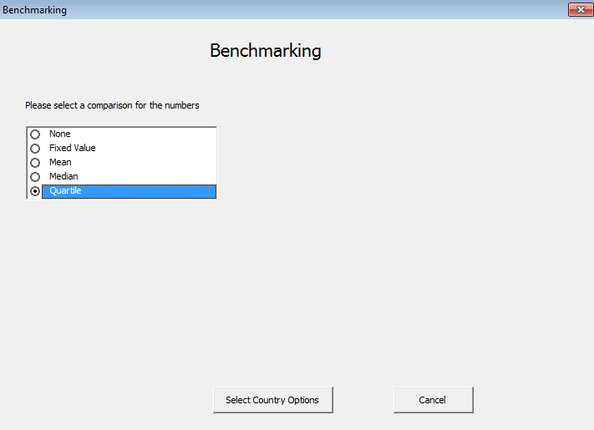
Click Quartile to begin.
Click on the “Select Countries Options” to move proceed.
Step 5

See Steps 2-4 on page 27 (section - benchmarking of countries) for a refresher on how to select countries and year range for analysis. We have not repeated those steps here to save space.

To understand the analysis table, interpret each indicator by identifying which countries fall below 25th percentile, are at the median, or above 75th percentile for a particular indicator. In this analysis table For example, in the quartile analysis table (see next page), the lower quartile for total fertility rate is 4.4 indicating that in 25% or lower of the EPCMD countries women average number of children that would be born to a woman over her lifetime would be equal to 4.4. However, in 75% of EPCMD countries woman would have between 6.0 and 6.6 children over her life time. You can interpret the findings similarly for other selected indicators.

Second, the table provides the opportunity to examine countries across the various selected variables and identify which countries overall are consistently in the lower quartile of selected indicators or which countries are above the upper quartile indicating overall lower or higher performance respectively on selected indicators. We observe that Afghanistan, Ethiopia and Yemen have worst health system performance indicators among EPCMD countries, while Indonesia and India are the best performers.
Note: Be aware of the higher values, which are shown in light blue actually indicate a worse situation when it comes to indicators such as infant and maternal mortality. Be careful when completing an interpretation.

Take home messages:
- Use your discretion to select whether quartile is the best option for benchmarking based on analysis question.
- Quartile is a good option when you want to explore the distribution of data points.
- First, compare where countries stand against each other on a specific indicator.
- Second, assess overall best and worst performing countries comparing across the selected indicators.

Table : Benchmarking using quartiles; All years reviewed from 2000 to 2014
Country | TFR_r_  WHO | MMR | NMR  _none | IMR  _none | U5MR  _none | Underweight  _Prev
Afghanistan |  | 400.00
Bangladesh | 2.70 | 170.00 | 42.60 | 69.50 | 87.60 | 40.80
Congo, DR | 7.40 | 730.00 | 31.40 | 71.40 | 121.00
Ethiopia | 5.90 | 420.00 | 45.90 | 80.60 | 119.50 | 28.80
Ghana | 5.00 | 380.00 | 38.30 | 61.60 | 102.10 | 13.80
Haiti | 4.40 | 380.00 | 36.40 | 71.80 | 113.60 | 17.70
India | 3.10 | 190.00 | 52.10 | 77.80 | 105.70 | 42.50
Indonesia | 2.70 | 190.00 | 31.40 | 66.30 | 97.70
Kenya | 5.20 | 400.00 | 38.60 | 63.60 | 86.00 | 16.00
Liberia | 6.20 | 640.00 | 34.00 | 74.80 | 120.10 | 18.10
Madagascar | 5.40 | 440.00 | 22.90 | 59.30 | 96.70 | 35.70
Malawi | 6.10 | 510.00 | 28.60 | 70.20 | 135.80 | 12.70
Mali | 6.80 | 550.00 | 36.20 | 63.30 | 105.50 | 27.00
Mozambique | 6.60 | 480.00 | 32.70 | 70.50 | 108.30 | 19.80
Nepal | 2.90 | 190.00 | 40.20 | 62.00 | 73.10 | 28.50
Nigeria |  | 560.00
Pakistan |  | 170.00
Rwanda | 5.10 | 320.00 | 32.50 | 74.60 | 123.40 | 11.40
Senegal | 6.50 | 320.00 | 33.50 | 54.30 | 81.70 | 13.70
South Sudan |  | 730.00
Tanzania | 6.20 | 410.00 | 25.20 | 63.00 | 96.50 | 15.60
Uganda | 7.00 | 360.00 | 32.60 | 78.80 | 133.10 | 15.80
Yemen, Rep. |  | 270.00
Zambia | 7.30 | 280.00 | 39.30 | 85.70 | 145.50 | 14.30
Quartile 1 - 25% | 4.40 | 272.50 | 31.40 | 63.00 | 96.50 | 14.05
Quartile 2 - 50% | 5.90 | 390.00 | 34.00 | 70.20 | 105.70 | 17.70
Quartile 3 - 75% | 6.60 | 502.50 | 39.30 | 74.80 | 121.00 | 28.65
Quartile 4 - 100% | 7.40 | 730.00 | 52.10 | 85.70 | 145.50 | 42.50
Legend
Quartile | Quartile 1 | Quartile 2 | Quartile 3 | Top Quarter
Missing data is blank

Clustering/Matching Countries

Introduction
In previous sections, we have compared countries on health system indicators or conducted benchmarking among countries using certain standards or parameters for health system indicators. These are valid comparisons; however, we have not matched these countries on similar socio-economic and demographic characteristics that could affect comparison of the health system indicators. Socio-economic determinants of health not only affect health in general, but also the evolution and performance of health systems in a given country, therefore, it is better to match countries on similar socio-economic and demographic characteristics to control for their effects.
Thus, we compare apple with apple and not apple with orange. We need to qualify our comparison by describing potential reasons which could affect the comparison when countries are not matched on similar socio-economic characteristics. However, you might have seen the literature where the countries are compared without describing the inherent biases in that comparison. To avoid selection and comparison biases intruding in the comparison it is always better to first group countries sharing common characteristics to limit comparison biases. Using countries with similar gross national income (GNI) or gross domestic products (GDP) is a common practice as done under the World Bank classification. The socio-economic and demographic determinants of health may differ in different income countries and may have their own independent effects; therefore, these determinants need to be matched before comparing countries on the health system indicators.
Cluster analysis is one way of putting observations into natural groups. There are different types of cluster analyses available. We have decided to use the partition method because of its simplicity, which brings observations into distinct non-overlapping groups. Most common clustering partition methods are k-mean and k-median. Group mean or median are used to create groups of selected variables closer to each other. In both methods, the user specifies the number of clusters (k) to create groups using an iterative process. Each observation is assigned to the group whose mean is closest, and then based on that categorization, new group means are determined. These steps continue until no observations change groups. The groups are created based on the proximity of the variable to group mean. The same process is repeated if the median is chosen instead of mean. Since median is not affected by extreme values, many prefer to use k-median analysis, especially, when there are large variations within variables.

The tool allows the creation of 2 to 5 clusters by selecting up to 10 indicators to make calculations manageable. The Excel is not suited for more complex cluster analysis. There is no standard way to determine number of clusters. Since the maximum number of allowed cluster is 5, we would recommend using it first to get the maximum clusters within the data. If the countries are mainly clustered around three clusters with a country in a cluster alone, we would recommend running the analysis again with two or three clusters (k) to see if the cluster groups change.

Please note: Like any analysis involving missing information, the variable with missing values are dropped out of the calculation. The same is true for cluster analysis. Therefore, It is important to first check that the selected countries have information on the variables of interest for cluster analysis. You can get that information by using benchmarking tab described on page 26- selecting “option none” under benchmarking parameter; selecting countries and variables of interest. This analysis will provide a table showing missing values by country. This will give you the opportunity to determine of there is enough information for a cluster analysis.

Sometime, you will find that you can drop a variable from the cluster analysis because many countries do not have that information. Similarly, one or two countries that do not have information on multiple variables can be dropped from the analysis.

Since we are only interested in matching countries on their background characteristics to control for their effects on health system indicators, we recommend that the user should only utilize socio-economic and demographic characteristics for matching countries. The major variables of interest could be GNI (preferable because it includes both GDP and foreign remittances) GDP, people living in absolute poverty, literacy, urban population, safe drinking water, sanitation and mobile phones to observe level of use of information technology. Any combination of countries can be included from regions or income classification for this cluster analysis. If you want to use only income or regional classification then there is no need for clustering, as these groups already exist and can be compared through benchmarking.

Selecting the method of clustering should be based on level of variability in the data. We suggest the user conduct cluster analysis using methods, mean and median, to understand variability. If the mean and median are close the cluster groups would not be very different from each other no matter what method is used.

The cluster analysis answer the following question:

- Do countries selected for health system indicators comparison share similar selected socio-economic characteristics? In other words, how many groups of countries exist of the selected countries data that share similar selected socio-economic characteristics?

By clicking on the “matching/clustering” tab, the following wondow will appear for selection of set of countries to match.

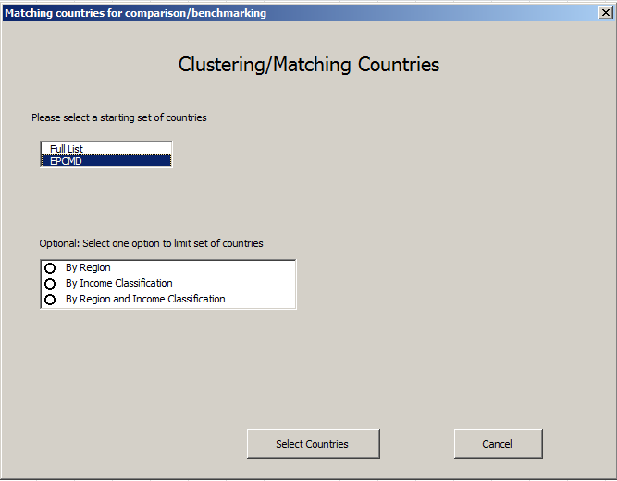
Select which country list you would like to use to select your countries of interest.
The same option to limit set countries by region and/or income classification is available.
Click “Select Countries” to proceed.

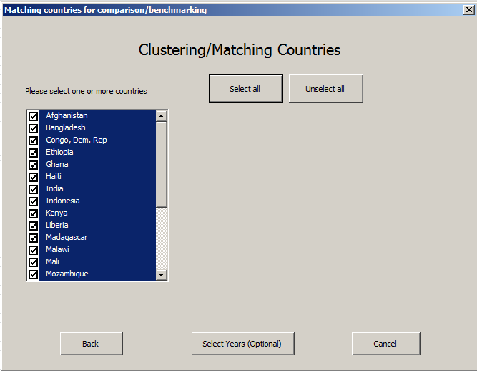
Select the countries of interest for clustering. At least 2 countries should be selected.
Click “Select Years (optional)” to proceed.

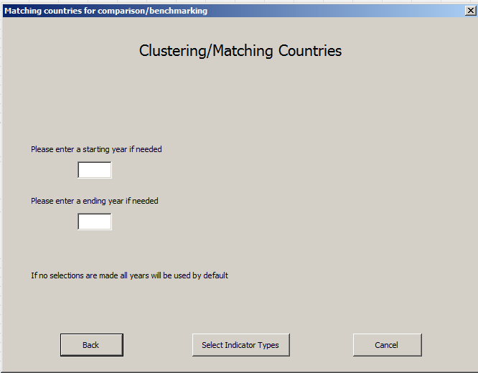
Select the time period for benchmarking the cluster.
If no start or end year is selected than all years will be analyzed.
Click “Select Indicator Types” to proceed.

Step 3
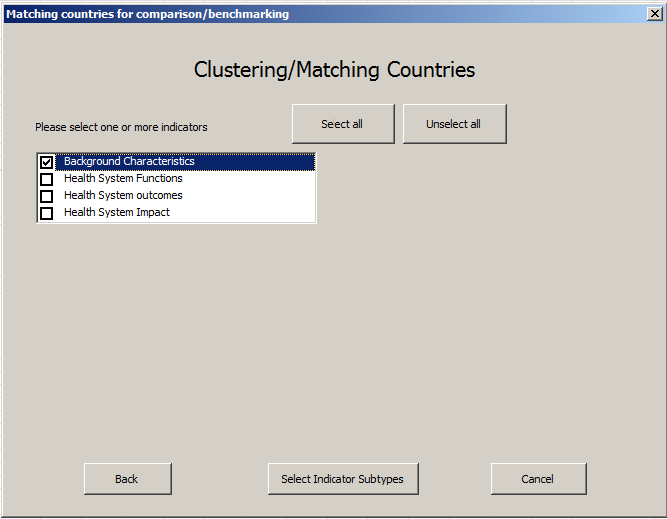
As noted, we want to group countries sharing similar socio-economic characteristics, therefore, select “background characteristics” only.

Click “Select indicator subtype” to proceed.

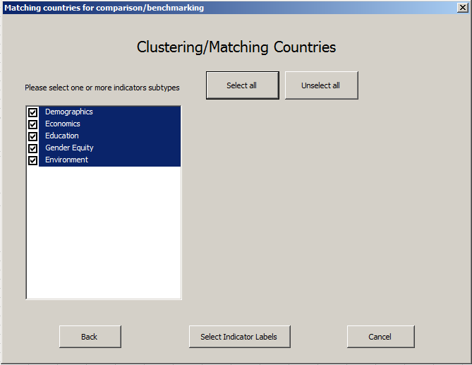
Click “Select all” or select individual economic indicators.

Click “Select Indicator Labels” to proceed.
However, if you have specific indicator(s) under specific subgroup(s) then click only those “sub-group boxes”

Step 4
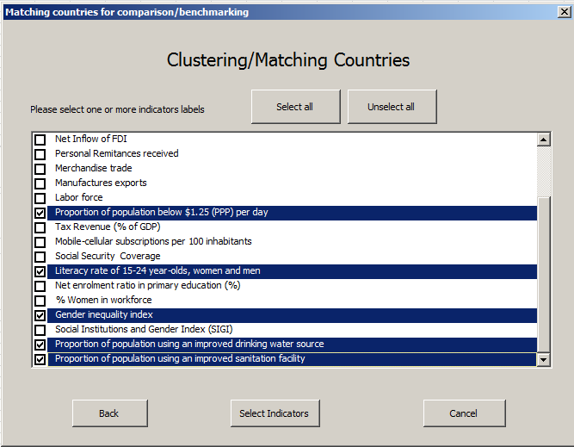
Step 5
Based on your analysis questions and selected socio-economic groups. At least 2 indicators should be selected for clustering.
Click “Select Indicators” to proceed.

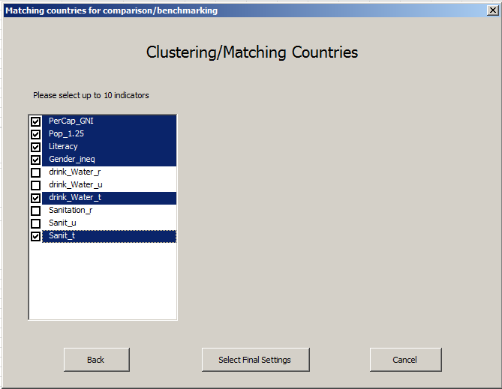
Step 6
Choose up to 10 disaggregated indicators of interest.

Click “Select Final Settings” to proceed.

Select final settings include a) selecting number of clusters; b) method of clustering; c) ignore country or indicators if the data is missing (see screen shot below). A) Selecting clusters: We recommend starting with maximum clusters and then running the analysis again if there is less number of clusters found. B) Method clustering: We suggest that the analyst conduct cluster analysis using methods, mean and median, to understand variability because if the mean and median are closer to the cluster groups would not be very different from each other irrespective of which method is used. C) Ignore country or indicators if the data is missing
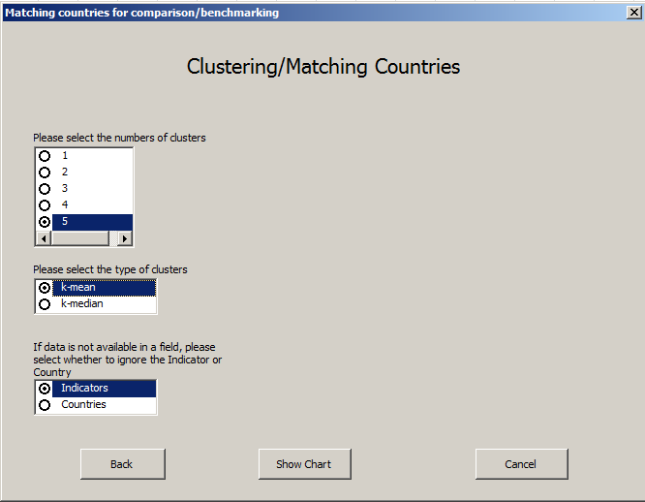
Step 7
We recommend starting with 5 clusters if clustering many countries.
Use “indicators option” when all countries have data on selected variables. This method will exclude indicators with missing data, as it clusters countries using the available indicator data.
Click “Show chart” to get the analysis tables 1 and 2.
Select Clustering method.

Clustering using k-mean
Clustering is only conducted when there is no missing information since countries with missing data will be dropped making clustering meaningless. Please note that if we select countries and background indicators for clustering, two situations can occur.
- The countries have data on many indicators but if the countries have missing information on one or more indicator then that the country would be dropped and only countries with complete information on indicators will be used for clustering analysis. In other words, clustering/matching will be based on few indicators and would be of limited use.
- We keep the countries with all selected indicators with information to make the matching useful and allow those countries to drop which lack information on all selected variables. This option will reduce the number of countries and we would not know which groups the dropped countries belong to.
Both these options have limitations and we would encourage analyst to use her/his discretion or use both to see how they can be of use. We have presented both options and how the results would look like.

Select indicator option
This option will drop indicators if information is missing. However, it will keep all selected countries with only those indicators which have full information. list of countries
The analysis will show two tables.
In Table 1, the “Cellular column” shows the number of the clusters/groups created. The groups are displayed in different colors to easily identify them. In addition, the groups are presented in descending order. The Table 1 does not provide good visualization of which indicators were dropped from the analysis, unless it is assumed that indicators with missing information will be dropped from the analysis.
To get a better understanding of how many and which indicators were used in the clustering, please review the Table 2. Table 2 provides information about the centroid as well as about how many indicators are used in clustering. In our example, only two indicators, per capita GNI and cellular phones, out of six selected indicator were used to group countries. The five other indicators from the original selection contained missing data and were dropped from the analysis.
From this analysis we can see Ghana and Zambia are more similar on these characteristics with India, Pakistan and Yemen than with their neighboring countries in Africa. However, we are not sure if information on variables that were dropped would have changed the results in the analysis. In this case a statement should be made to qualify that matching variables are few in number countries were compared with similar background characteristics.

Table 1: Cluster analysis using K-Mean with EPCMD countries and selected socio-economic indicators; Option indicator
Indicators with missing data are not used in the k-mean calculations
Country | PerCap_GNI | Pop_1.25 | Literacy | Cellular | Gender_inequality | drinking_Water_rural | Sanitation_rural | k-mean Cluster
Bangladesh | 1010.00 | 43.25 | 57.70 | 63.00 | 0.53 | 84.00 | 58.00 | 1
Kenya | 1160.00 | 43.37 | 87.40 | 71.00 | 0.55 | 55.00 | 29.00 | 1
Senegal | 1050.00 | 34.06 |  | 84.00 | 0.54 | 60.00 | 40.00 | 1
South Sudan | 950.00 |  |  | 21.00 |  | 55.00 | 7.00 | 1
Tanzania | 860.00 | 43.48 | 73.20 | 57.00 | 0.55 | 44.00 | 7.00 | 1
Ghana | 1770.00 | 28.59 | 67.30 | 101.00 | 0.55 | 81.00 | 8.00 | 2
India | 1570.00 | 24.68 |  | 70.00 | 0.56 | 91.00 | 25.00 | 2
Pakistan | 1360.00 | 12.74 |  | 67.00 |  |  |  | 2
Yemen, Rep. | 1330.00 | 9.78 | 65.30 | 58.00 | 0.73 |  |  | 2
Zambia | 1810.00 | 74.32 | 71.20 | 75.00 | 0.62 | 49.00 | 34.00 | 2
Congo, DR | 430.00 | 32.82 | 66.80 | 31.00 | 0.67 | 29.00 | 33.00 | 3
Ethiopia | 470.00 | 36.79 |  | 22.00 | 0.55 | 42.00 | 23.00 | 3
Liberia | 410.00 | 83.76 | 60.80 | 57.00 | 0.66 | 63.00 | 6.00 | 3
Madagascar | 440.00 | 87.67 |  | 39.00 |  | 35.00 | 11.00 | 3
Malawi | 270.00 | 72.16 | 74.80 | 29.00 | 0.59 | 83.00 | 8.00 | 3
Afghanistan | 690.00 |  |  | 60.00 | 0.71 | 56.00 | 23.00 | 4
Haiti | 810.00 | 61.71 |  | 60.00 | 0.60 | 47.00 | 16.00 | 4
Mali | 670.00 | 50.61 | 33.40 | 98.00 | 0.67 | 54.00 | 15.00 | 4
Mozambique | 610.00 | 60.71 | 56.10 | 36.00 | 0.66 | 35.00 | 11.00 | 4
Nepal | 730.00 | 23.74 | 57.40 | 60.00 | 0.48 | 88.00 | 34.00 | 4
Rwanda | 630.00 | 63.02 | 65.90 | 50.00 | 0.41 | 68.00 | 64.00 | 4
Uganda | 600.00 | 37.78 | 73.20 | 45.00 | 0.53 | 71.00 | 34.00 | 4
Indonesia | 3580.00 | 16.20 | 92.80 | 114.00 | 0.50 | 76.00 | 46.00 | 5
Nigeria | 2710.00 | 62.03 | 61.30 | 67.00 |  |  |  | 5

Table 2: Display of cluster centroids based on indicators used;
Recap of columns used in calculations
 | PerCap_GNI | Cellular
Centroid 1 | 1006.00 | 59.20
Centroid 2 | 1568.00 | 74.20
Centroid 3 | 404.00 | 35.60
Centroid 4 | 677.14 | 58.43
Centroid 5 | 3145.00 | 90.50

Select country option
This option selects only those countries with complete information on all selected Indicators and dropped countries with one or more selected indicators that have missing information. The advantage is that all those countries are selected where each country has all information on the selected indicators. More indicators are used for grouping countries and thus better matching of countries, which is not possible when indicators option is selected because it excludes the country if the country has missing information only in one indicator. Like the indicator option, the process results in small number of countries grouped because countries with any indicator with missing data are dropped from analysis.
Caution: This option is okay when we want countries with all information on selected indicators are to be grouped. It provides a better visualization of dropped countries because of missing information.

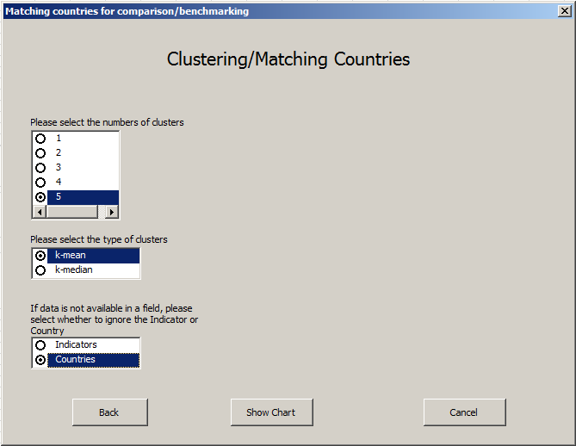
We recommend starting with 5 clusters, if the selected countries are large in number.
Use “countries option” to cluster all countries only with complete information on selected indicators. It will exclude countries with missing information. This allows for better matching of countries.
Click “Show chart” to get the analysis tables 1 and 2.
Click on the method of clustering. Here we have selected k-mean.
 | Table 3: Cluster analysis using K-Mean with EPCMD countries and selected socio-economic indicators.; Option countries
 | All years reviewed from 2000 to 2014; Countries with missing data are not used in the k-mean calculations
 | Country |  | PerCap  GNI |  | Pop_1.25 |  | Literacy |  | Cellular | Gender_  inequality | Drinking_  Waterrural |  | Sanitation  _rural |  | k-mean Cluster1
 | Bangladesh |  | 1010.00 |  | 43.25 |  | 57.70 |  | 63.00 | 0.53 | 84.00 |  | 58.00 |  | 1
 | Nepal |  | 730.00 |  | 23.74 |  | 57.40 |  | 60.00 | 0.48 | 88.00 |  | 34.00 |  | 1
 | Tanzania |  | 860.00 |  | 43.48 |  | 73.20 |  | 57.00 | 0.55 | 44.00 |  | 7.00 |  | 1
 | Congo, D R |  | 430.00 |  | 32.82 |  | 66.80 |  | 31.00 | 0.67 | 29.00 |  | 33.00 |  | 2
 | Liberia |  | 410.00 |  | 83.76 |  | 60.80 |  | 57.00 | 0.66 | 63.00 |  | 6.00 |  | 2
 | Malawi |  | 270.00 |  | 72.16 |  | 74.80 |  | 29.00 | 0.59 | 83.00 |  | 8.00 |  | 2
 | Mali |  | 670.00 |  | 50.61 |  | 33.40 |  | 98.00 | 0.67 | 54.00 |  | 15.00 |  | 2
 | Mozambique |  | 610.00 |  | 60.71 |  | 56.10 |  | 36.00 | 0.66 | 35.00 |  | 11.00 |  | 2
 | Rwanda |  | 630.00 |  | 63.02 |  | 65.90 |  | 50.00 | 0.41 | 68.00 |  | 64.00 |  | 2
 | Uganda |  | 600.00 |  | 37.78 |  | 73.20 |  | 45.00 | 0.53 | 71.00 |  | 34.00 |  | 2
 | Ghana |  | 1770.00 |  | 28.59 |  | 67.30 |  | 101.00 | 0.55 | 81.00 |  | 8.00 |  | 3
 | Zambia |  | 1810.00 |  | 74.32 |  | 71.20 |  | 75.00 | 0.62 | 49.00 |  | 34.00 |  | 3
 | Indonesia |  | 3580.00 |  | 16.20 |  | 92.80 |  | 114.00 | 0.50 | 76.00 |  | 46.00 |  | 4
 | Kenya |  | 1160.00 |  | 43.37 |  | 87.40 |  | 71.00 | 0.55 | 55.00 |  | 29.00 |  | 5
 | Afghanistan |  | 690.00 |  |  |  |  |  | 60.00 | 0.71 | 56.00 |  | 23.00
 | Ethiopia |  | 470.00 |  | 36.79 |  |  |  | 22.00 | 0.55 | 42.00 |  | 23.00
 | Haiti |  | 810.00 |  | 61.71 |  |  |  | 60.00 | 0.60 | 47.00 |  | 16.00
 | India |  | 1570.00 |  | 24.68 |  |  |  | 70.00 | 0.56 | 91.00 |  | 25.00
 | Madagascar |  | 440.00 |  | 87.67 |  |  |  | 39.00 |  | 35.00 |  | 11.00
 | Nigeria |  | 2710.00 |  | 62.03 |  | 61.30 |  | 67.00
 | Pakistan |  | 1360.00 |  | 12.74 |  |  |  | 67.00
 | Senegal |  | 1050.00 |  | 34.06 |  |  |  | 84.00 | 0.54 | 60.00 |  | 40.00
 | South Sudan |  | 950.00 |  |  |  |  |  | 21.00 |  | 55.00 |  | 7.00
 | Yemen, Rep. |  | 1330.00 |  | 9.78 |  | 65.30 |  | 58.00 | 0.73
Table 4: Display of cluster centroids ; Recap of columns used in calculations
 |  | PerCap  _GNI |  | Pop_1.25 |  | Literacy |  | Cellular |  | Gender_  inequality |  | drinking_  Water_rural |  | Sanitation  _rural
Centroid 1 |  | 866.67 |  | 36.82 |  | 62.77 |  | 60.00 |  | 0.52 |  | 72.00 |  | 33.00
Centroid 2 |  | 517.14 |  | 57.27 |  | 61.57 |  | 49.43 |  | 0.60 |  | 57.57 |  | 24.43
Centroid 3 |  | 1790.00 |  | 51.46 |  | 69.25 |  | 88.00 |  | 0.58 |  | 65.00 |  | 21.00
Centroid 4 |  | 3580.00 |  | 16.20 |  | 92.80 |  | 114.00 |  | 0.50 |  | 76.00 |  | 46.00
Centroid 5 |  | 1160.00 |  | 43.37 |  | 87.40 |  | 71.00 |  | 0.55 |  | 55.00 |  | 29.00

The Table 3 shows that selected countries have five groups. However, group four and five have only one country each, indicating that the grouping may be more refined using a lower clustering number. Table 3 also showed that majority of the countries fall in group 2, while 2 and 3 countries are part of groups 3 and 2 respectively. Table 4 shows the centroid of the clusters around which the countries are grouped.
The Table 3, which is based on “option of countries”, shows less number of countries (14) selected for analysis compared to Table 1 based on “indicator option” where all 24 countries were used, because the selected countries contain information on all selected indicators (7), while in Table 1, there were only two indicators used for analysis. The dropped countries are shown in the Table 3 without any color. This comparison shows weakness of these two techniques of displaying clustered data
Recommendation: Due to missing information, we recommend that you use both options to observe whether the groupings have changed. As a general rule, it is better to match countries with more variables before making comparisons among them.
Please Note: When selecting “option indicator” for clustering there is possibility that all the selected countries may have one or more values missing in the selected variables. Thus, you will come across the following message.

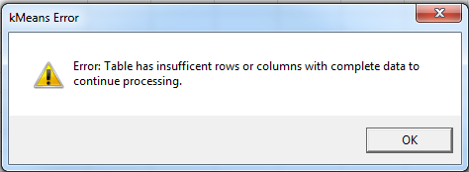

In our previous example, we tried to conduct the clustering analysis without GNI indicator using “indicator option” and the above error message appeared. Table 5 illustrates that when the countries have missing data in any indicator, highlighted in yellow, the clustering stops. In addition, having only indicator with complete information, cellular data in Table 5, still does not allow the clustering to proceed.
Note: At least two or more indicators from all countries are required for clustering; therefore, this analysis could not be completed.

Table 5: Cluster analysis socio-economic variables excluding GNI not conducted using “clustering option indicator”; Missing values highlighted in Yellow
All years reviewed from 2000 to 2014; Indicators with missing data are not used in the k-mean calculations
Country | Pop_1.25 | Literacy | Cellular | Gender_inequality | drinking_Water  _rural | Sanitation  _rural
Afghanistan |  |  | 60.00 | 0.71 | 56.00 | 23.00
Bangladesh | 43.25 | 57.70 | 63.00 | 0.53 | 84.00 | 58.00
Congo, DR | 32.82 | 66.80 | 31.00 | 0.67 | 29.00 | 33.00
Ethiopia | 36.79 |  | 22.00 | 0.55 | 42.00 | 23.00
Ghana | 28.59 | 67.30 | 101.00 | 0.55 | 81.00 | 8.00
Haiti | 61.71 |  | 60.00 | 0.60 | 47.00 | 16.00
India | 24.68 |  | 70.00 | 0.56 | 91.00 | 25.00
Indonesia | 16.20 | 92.80 | 114.00 | 0.50 | 76.00 | 46.00
Kenya | 43.37 | 87.40 | 71.00 | 0.55 | 55.00 | 29.00
Liberia | 83.76 | 60.80 | 57.00 | 0.66 | 63.00 | 6.00
Madagascar | 87.67 |  | 39.00 |  | 35.00 | 11.00
Malawi | 72.16 | 74.80 | 29.00 | 0.59 | 83.00 | 8.00
Mali | 50.61 | 33.40 | 98.00 | 0.67 | 54.00 | 15.00
Mozambique | 60.71 | 56.10 | 36.00 | 0.66 | 35.00 | 11.00
Nepal | 23.74 | 57.40 | 60.00 | 0.48 | 88.00 | 34.00
Nigeria | 62.03 | 61.30 | 67.00
Pakistan | 12.74 |  | 67.00
Rwanda | 63.02 | 65.90 | 50.00 | 0.41 | 68.00 | 64.00
Senegal | 34.06 |  | 84.00 | 0.54 | 60.00 | 40.00
South Sudan |  |  | 21.00 |  | 55.00 | 7.00
Tanzania | 43.48 | 73.20 | 57.00 | 0.55 | 44.00 | 7.00
Uganda | 37.78 | 73.20 | 45.00 | 0.53 | 71.00 | 34.00
Yemen, Rep. | 9.78 | 65.30 | 58.00 | 0.73
Zambia | 74.32 | 71.20 | 75.00 | 0.62 | 49.00 | 34.00

Please note that “countries option” clustering analysis has produced Table 6, indicating that all countries with information on all selected indicators were used for clustering. Since Table 6 excludes GNI, it would be nice to compare it with Table 3, where GNI was included to observe any influence of GNI on the cluster grouping. This should be a general rule to observe the effect of a single indicator with large values.

Table 6: Cluster analysis socio-economic variables excluding GNI using “clustering option countries” & 5 clusters
All years reviewed from 2000 to 2014; Countries with missing data are not used in the k-mean calculations
Country | Pop_1.25 | Literacy | Cellular | Gender_  inequality | drinking_Water  _rural | Sanitation  rural | k-mean Cluster3
Bangladesh | 43.25 | 57.70 | 63.00 | 0.53 | 84.00 | 58.00 | 1
Nepal | 23.74 | 57.40 | 60.00 | 0.48 | 88.00 | 34.00 | 1
Rwanda | 63.02 | 65.90 | 50.00 | 0.41 | 68.00 | 64.00 | 1
Uganda | 37.78 | 73.20 | 45.00 | 0.53 | 71.00 | 34.00 | 1
Congo, DR | 32.82 | 66.80 | 31.00 | 0.67 | 29.00 | 33.00 | 2
Mozambique | 60.71 | 56.10 | 36.00 | 0.66 | 35.00 | 11.00 | 2
Ghana | 28.59 | 67.30 | 101.00 | 0.55 | 81.00 | 8.00 | 3
Mali | 50.61 | 33.40 | 98.00 | 0.67 | 54.00 | 15.00 | 3
Indonesia | 16.20 | 92.80 | 114.00 | 0.50 | 76.00 | 46.00 | 4
Kenya | 43.37 | 87.40 | 71.00 | 0.55 | 55.00 | 29.00 | 5
Liberia | 83.76 | 60.80 | 57.00 | 0.66 | 63.00 | 6.00 | 5
Malawi | 72.16 | 74.80 | 29.00 | 0.59 | 83.00 | 8.00 | 5
Tanzania | 43.48 | 73.20 | 57.00 | 0.55 | 44.00 | 7.00 | 5
Zambia | 74.32 | 71.20 | 75.00 | 0.62 | 49.00 | 34.00 | 5
Afghanistan |  |  | 60.00 | 0.71 | 56.00 | 23.00
Ethiopia | 36.79 |  | 22.00 | 0.55 | 42.00 | 23.00
Haiti | 61.71 |  | 60.00 | 0.60 | 47.00 | 16.00
India | 24.68 |  | 70.00 | 0.56 | 91.00 | 25.00
Madagascar | 87.67 |  | 39.00 |  | 35.00 | 11.00
Nigeria | 62.03 | 61.30 | 67.00
Pakistan | 12.74 |  | 67.00
Senegal | 34.06 |  | 84.00 | 0.54 | 60.00 | 40.00
South Sudan |  |  | 21.00 |  | 55.00 | 7.00
Yemen, Rep. | 9.78 | 65.30 | 58.00 | 0.73

Table 7 shows the centroid of the clusters around which the countries are grouped.
Recommendation: As a general rule, always conduct clustering with and without variables with high or very low values to observe their effect on clustering. Use your discretion and rationale for including one or other or both for reporting analysis and its implications.

Table 7: Display of cluster centroids; Recap of columns used in calculations
 | Pop_1.25 | Literacy | Cellular | Gender_  inequality | drinking_  Water_rural | Sanitation  _rural
Centroid 1 | 41.95 | 63.55 | 54.50 | 0.49 | 77.75 | 47.50
Centroid 2 | 46.77 | 61.45 | 33.50 | 0.66 | 32.00 | 22.00
Centroid 3 | 39.60 | 50.35 | 99.50 | 0.61 | 67.50 | 11.50
Centroid 4 | 16.20 | 92.80 | 114.00 | 0.50 | 76.00 | 46.00
Centroid 5 | 63.42 | 73.48 | 57.80 | 0.59 | 58.80 | 16.80

Since there is only one country in cluster 4 (Indonesia) in Table 6, we ran the analysis again to see how the grouping would change if there were 4 clusters.
Table 8 shows that the cluster 1 and 5 from Table 6 merged to produce cluster 1 in the new cluster analysis. Tanzania moved from cluster 5 to cluster 2 joining Congo and Mozambique. Indonesia kept its distinct one country group position. When comparing Table 7 and Table 9 the centroids also did not change much for clusters 2, 3, and 4. Since the cluster 1 and 5 become one cluster their centroids changed too.

Table 8: Cluster analysis socio-economic variables using “clustering option countries” & 4 clusters
All years reviewed from 2000 to 2014; Countries with missing data are not used in the k-mean calculations
Country | Pop_1.25 | Literacy | Cellular | Gender  _inequality | drinking_  Water_rural | Sanitation  _rural | k-mean Cluster4
Bangladesh | 43.25 | 57.70 | 63.00 | 0.53 | 84.00 | 58.00 | 1
Kenya | 43.37 | 87.40 | 71.00 | 0.55 | 55.00 | 29.00 | 1
Liberia | 83.76 | 60.80 | 57.00 | 0.66 | 63.00 | 6.00 | 1
Malawi | 72.16 | 74.80 | 29.00 | 0.59 | 83.00 | 8.00 | 1
Nepal | 23.74 | 57.40 | 60.00 | 0.48 | 88.00 | 34.00 | 1
Rwanda | 63.02 | 65.90 | 50.00 | 0.41 | 68.00 | 64.00 | 1
Uganda | 37.78 | 73.20 | 45.00 | 0.53 | 71.00 | 34.00 | 1
Zambia | 74.32 | 71.20 | 75.00 | 0.62 | 49.00 | 34.00 | 1
Congo, DR | 32.82 | 66.80 | 31.00 | 0.67 | 29.00 | 33.00 | 2
Mozambique | 60.71 | 56.10 | 36.00 | 0.66 | 35.00 | 11.00 | 2
Tanzania | 43.48 | 73.20 | 57.00 | 0.55 | 44.00 | 7.00 | 2
Ghana | 28.59 | 67.30 | 101.00 | 0.55 | 81.00 | 8.00 | 3
Mali | 50.61 | 33.40 | 98.00 | 0.67 | 54.00 | 15.00 | 3
Indonesia | 16.20 | 92.80 | 114.00 | 0.50 | 76.00 | 46.00 | 4
Afghanistan |  |  | 60.00 | 0.71 | 56.00 | 23.00
Ethiopia | 36.79 |  | 22.00 | 0.55 | 42.00 | 23.00
Haiti | 61.71 |  | 60.00 | 0.60 | 47.00 | 16.00
India | 24.68 |  | 70.00 | 0.56 | 91.00 | 25.00
Madagascar | 87.67 |  | 39.00 |  | 35.00 | 11.00
Nigeria | 62.03 | 61.30 | 67.00
Pakistan | 12.74 |  | 67.00
Senegal | 34.06 |  | 84.00 | 0.54 | 60.00 | 40.00
South Sudan |  |  | 21.00 |  | 55.00 | 7.00
Yemen, Rep. | 9.78 | 65.30 | 58.00 | 0.73

Table 9: Display of cluster centroids ; Recap of columns used in calculations
 | Pop_1.25 | Literacy | Cellular | Gender  _inequality | drinking_  Water_rural | Sanitation  _rural
Centroid 1 | 55.18 | 68.55 | 56.25 | 0.54 | 70.13 | 33.38
Centroid 2 | 45.67 | 65.37 | 41.33 | 0.63 | 36.00 | 17.00
Centroid 3 | 39.60 | 50.35 | 99.50 | 0.61 | 67.50 | 11.50
Centroid 4 | 16.20 | 92.80 | 114.00 | 0.50 | 76.00 | 46.00

An analysis with 3 clusters was also completed to create groups with adequate number of countries for comparison. The 3 cluster solution merged Indonesia into cluster 3, shown in Table 10 and made the groups more comparable with adequate number of countries in each group. Please note that Indonesia as a cluster was closer to closer 3, as the centroid in Table 11 showed and was natural to fall in that group.
Table 10: Cluster analysis socio-economic variables using “clustering option indicator” & 3 clusters
All years reviewed from 2000 to 2014; Countries with missing data are not used in k-mean calculations
Country | Pop_1.25 | Literacy | Cellular | Gender  _inequality | Drinking  _Water_rural | Sanitation  _rural | k-mean Cluster5
Bangladesh | 43.25 | 57.70 | 63.00 | 0.53 | 84.00 | 58.00 | 1
Kenya | 43.37 | 87.40 | 71.00 | 0.55 | 55.00 | 29.00 | 1
Liberia | 83.76 | 60.80 | 57.00 | 0.66 | 63.00 | 6.00 | 1
Malawi | 72.16 | 74.80 | 29.00 | 0.59 | 83.00 | 8.00 | 1
Nepal | 23.74 | 57.40 | 60.00 | 0.48 | 88.00 | 34.00 | 1
Rwanda | 63.02 | 65.90 | 50.00 | 0.41 | 68.00 | 64.00 | 1
Uganda | 37.78 | 73.20 | 45.00 | 0.53 | 71.00 | 34.00 | 1
Zambia | 74.32 | 71.20 | 75.00 | 0.62 | 49.00 | 34.00 | 1
Congo, DR | 32.82 | 66.80 | 31.00 | 0.67 | 29.00 | 33.00 | 2
Mozambique | 60.71 | 56.10 | 36.00 | 0.66 | 35.00 | 11.00 | 2
Tanzania | 43.48 | 73.20 | 57.00 | 0.55 | 44.00 | 7.00 | 2
Ghana | 28.59 | 67.30 | 101.00 | 0.55 | 81.00 | 8.00 | 3
Indonesia | 16.20 | 92.80 | 114.00 | 0.50 | 76.00 | 46.00 | 3
Mali | 50.61 | 33.40 | 98.00 | 0.67 | 54.00 | 15.00 | 3
Afghanistan |  |  | 60.00 | 0.71 | 56.00 | 23.00
Ethiopia | 36.79 |  | 22.00 | 0.55 | 42.00 | 23.00
Haiti | 61.71 |  | 60.00 | 0.60 | 47.00 | 16.00
India | 24.68 |  | 70.00 | 0.56 | 91.00 | 25.00
Madagascar | 87.67 |  | 39.00 |  | 35.00 | 11.00
Nigeria | 62.03 | 61.30 | 67.00
Pakistan | 12.74 |  | 67.00
Senegal | 34.06 |  | 84.00 | 0.54 | 60.00 | 40.00
South Sudan |  |  | 21.00 |  | 55.00 | 7.00
Yemen, Rep. | 9.78 | 65.30 | 58.00 | 0.73

Table 11: Display of cluster centroids; Recap of columns used in calculations
 | Pop_1.25 | Literacy | Cellular | Gender_  inequality | drinking_  Water_rural | Sanitation  _rural
Centroid 1 | 55.18 | 68.55 | 56.25 | 0.54 | 70.13 | 33.38
Centroid 2 | 45.67 | 65.37 | 41.33 | 0.63 | 36.00 | 17.00
Centroid 3 | 31.80 | 64.50 | 104.33 | 0.57 | 70.33 | 23.00

Clustering using k-median

The process of clustering based on median is same as the mean. There are the same options of using indicators or countries for display of dropped indicator or countries. We repeated the clustering analysis using median, keeping all indicators and countries the same. Like the clustering analysis using mean, the analysis could not be conducted using “indicator option” for median. The following error message appeared:

We presented Table 12 to show that all countries have at least one missing indicator value causing clustering to stop. Thus, we have used the “countries option” to conduct cluster analysis with countries having all information on selected indicators.

Table 12: Cluster analysis socio-economic variables excluding GNI not conducted using “clustering option Median and indicator” Missing values highlighted in Yellow
All years reviewed 2000 -2014; Indicators with missing data are not used in the k-median
Country | Pop_1.25 | Literacy | Cellular | Gender  _inequality | drinking_  Water_rural | Sanitation_  rural
Afghanistan |  |  | 60.00 | 0.71 | 56.00 | 23.00
Bangladesh | 43.25 | 57.70 | 63.00 | 0.53 | 84.00 | 58.00
Congo, DR | 32.82 | 66.80 | 31.00 | 0.67 | 29.00 | 33.00
Ethiopia | 36.79 |  | 22.00 | 0.55 | 42.00 | 23.00
Ghana | 28.59 | 67.30 | 101.00 | 0.55 | 81.00 | 8.00
Haiti | 61.71 |  | 60.00 | 0.60 | 47.00 | 16.00
India | 24.68 |  | 70.00 | 0.56 | 91.00 | 25.00
Indonesia | 16.20 | 92.80 | 114.00 | 0.50 | 76.00 | 46.00
Kenya | 43.37 | 87.40 | 71.00 | 0.55 | 55.00 | 29.00
Liberia | 83.76 | 60.80 | 57.00 | 0.66 | 63.00 | 6.00
Madagascar | 87.67 |  | 39.00 |  | 35.00 | 11.00
Malawi | 72.16 | 74.80 | 29.00 | 0.59 | 83.00 | 8.00
Mali | 50.61 | 33.40 | 98.00 | 0.67 | 54.00 | 15.00
Mozambique | 60.71 | 56.10 | 36.00 | 0.66 | 35.00 | 11.00
Nepal | 23.74 | 57.40 | 60.00 | 0.48 | 88.00 | 34.00
Nigeria | 62.03 | 61.30 | 67.00
Pakistan | 12.74 |  | 67.00
Rwanda | 63.02 | 65.90 | 50.00 | 0.41 | 68.00 | 64.00
Senegal | 34.06 |  | 84.00 | 0.54 | 60.00 | 40.00
South Sudan |  |  | 21.00 |  | 55.00 | 7.00
Tanzania | 43.48 | 73.20 | 57.00 | 0.55 | 44.00 | 7.00
Uganda | 37.78 | 73.20 | 45.00 | 0.53 | 71.00 | 34.00
Yemen, Rep. | 9.78 | 65.30 | 58.00 | 0.73
Zambia | 74.32 | 71.20 | 75.00 | 0.62 | 49.00 | 34.00

Note: The cluster analysis using median is not very different from mean analysis except for few countries and that could have extreme values, which affect mean clustering but not median.
Table 13: Cluster analysis socio-economic variables using “clustering option countries” & 5 clusters
All years reviewed from 2000 to 2014; Countries with missing data are not used in the k-median calculations
Country | Pop_1.25 | Literacy | Cellular | Gender  _inequality | Drinking  _Water_rural | Sanitation  _rural | k-median Cluster1
Bangladesh | 43.25 | 57.70 | 63.00 | 0.53 | 84.00 | 58.00 | 1
Nepal | 23.74 | 57.40 | 60.00 | 0.48 | 88.00 | 34.00 | 1
Rwanda | 63.02 | 65.90 | 50.00 | 0.41 | 68.00 | 64.00 | 1
Congo, DR | 32.82 | 66.80 | 31.00 | 0.67 | 29.00 | 33.00 | 2
Mozambique | 60.71 | 56.10 | 36.00 | 0.66 | 35.00 | 11.00 | 2
Ghana | 28.59 | 67.30 | 101.00 | 0.55 | 81.00 | 8.00 | 3
Malawi | 72.16 | 74.80 | 29.00 | 0.59 | 83.00 | 8.00 | 3
Mali | 50.61 | 33.40 | 98.00 | 0.67 | 54.00 | 15.00 | 3
Indonesia | 16.20 | 92.80 | 114.00 | 0.50 | 76.00 | 46.00 | 4
Kenya | 43.37 | 87.40 | 71.00 | 0.55 | 55.00 | 29.00 | 5
Liberia | 83.76 | 60.80 | 57.00 | 0.66 | 63.00 | 6.00 | 5
Tanzania | 43.48 | 73.20 | 57.00 | 0.55 | 44.00 | 7.00 | 5
Uganda | 37.78 | 73.20 | 45.00 | 0.53 | 71.00 | 34.00 | 5
Zambia | 74.32 | 71.20 | 75.00 | 0.62 | 49.00 | 34.00 | 5
Afghanistan |  |  | 60.00 | 0.71 | 56.00 | 23.00
Ethiopia | 36.79 |  | 22.00 | 0.55 | 42.00 | 23.00
Haiti | 61.71 |  | 60.00 | 0.60 | 47.00 | 16.00
India | 24.68 |  | 70.00 | 0.56 | 91.00 | 25.00
Madagascar | 87.67 |  | 39.00 |  | 35.00 | 11.00
Nigeria | 62.03 | 61.30 | 67.00
Pakistan | 12.74 |  | 67.00
Senegal | 34.06 |  | 84.00 | 0.54 | 60.00 | 40.00
South Sudan |  |  | 21.00 |  | 55.00 | 7.00
Yemen, Rep. | 9.78 | 65.30 | 58.00 | 0.73

Table 14: Display of cluster centroids; Recap of columns used in calculations
 | Pop_1.25 | Literacy | Cellular | Gender  _inequality | drinking_  Water_rural | Sanitation  _rural
Centroid 1 | 43.25 | 57.70 | 60.00 | 0.48 | 84.00 | 58.00
Centroid 2 | 46.77 | 61.45 | 33.50 | 0.66 | 32.00 | 22.00
Centroid 3 | 50.61 | 67.30 | 98.00 | 0.59 | 81.00 | 8.00
Centroid 4 | 16.20 | 92.80 | 114.00 | 0.50 | 76.00 | 46.00
Centroid 5 | 43.48 | 73.20 | 57.00 | 0.55 | 55.00 | 29.00

Table 15: Cluster analysis socio-economic variables “clustering option countries” & 4 clusters
All years reviewed from 2000 to 2014; Countries with missing data are not used in the k-median calculations
Country | Pop_1.25 | Literacy | Cellular | Gender  _inequality | Drinking  _Water_rural | Sanitation  _rural | k-median Cluster3
Bangladesh | 43.25 | 57.70 | 63.00 | 0.53 | 84.00 | 58.00 | 1
Kenya | 43.37 | 87.40 | 71.00 | 0.55 | 55.00 | 29.00 | 1
Liberia | 83.76 | 60.80 | 57.00 | 0.66 | 63.00 | 6.00 | 1
Nepal | 23.74 | 57.40 | 60.00 | 0.48 | 88.00 | 34.00 | 1
Rwanda | 63.02 | 65.90 | 50.00 | 0.41 | 68.00 | 64.00 | 1
Congo, DR | 32.82 | 66.80 | 31.00 | 0.67 | 29.00 | 33.00 | 2
Mozambique | 60.71 | 56.10 | 36.00 | 0.66 | 35.00 | 11.00 | 2
Tanzania | 43.48 | 73.20 | 57.00 | 0.55 | 44.00 | 7.00 | 2
Uganda | 37.78 | 73.20 | 45.00 | 0.53 | 71.00 | 34.00 | 2
Zambia | 74.32 | 71.20 | 75.00 | 0.62 | 49.00 | 34.00 | 2
Ghana | 28.59 | 67.30 | 101.00 | 0.55 | 81.00 | 8.00 | 3
Malawi | 72.16 | 74.80 | 29.00 | 0.59 | 83.00 | 8.00 | 3
Mali | 50.61 | 33.40 | 98.00 | 0.67 | 54.00 | 15.00 | 3
Indonesia | 16.20 | 92.80 | 114.00 | 0.50 | 76.00 | 46.00 | 4
Afghanistan |  |  | 60.00 | 0.71 | 56.00 | 23.00
Ethiopia | 36.79 |  | 22.00 | 0.55 | 42.00 | 23.00
Haiti | 61.71 |  | 60.00 | 0.60 | 47.00 | 16.00
India | 24.68 |  | 70.00 | 0.56 | 91.00 | 25.00
Madagascar | 87.67 |  | 39.00 |  | 35.00 | 11.00
Nigeria | 62.03 | 61.30 | 67.00
Pakistan | 12.74 |  | 67.00
Senegal | 34.06 |  | 84.00 | 0.54 | 60.00 | 40.00
South Sudan |  |  | 21.00 |  | 55.00 | 7.00
Yemen, Rep. | 9.78 | 65.30 | 58.00 | 0.73

Table 16: Display of cluster centroids; Recap of columns used in calculations
 | Pop_1.25 | Literacy | Cellular | Gender  _inequality | Drinking  _Water_rural | Sanitation  _rural
Centroid 1 | 43.37 | 60.80 | 60.00 | 0.53 | 68.00 | 34.00
Centroid 2 | 43.48 | 71.20 | 45.00 | 0.62 | 44.00 | 33.00
Centroid 3 | 50.61 | 67.30 | 98.00 | 0.59 | 81.00 | 8.00
Centroid 4 | 16.20 | 92.80 | 114.00 | 0.50 | 76.00 | 46.00

Table 17: Cluster analysis socio-economic variables using “clustering option countries” & 3 clusters
All years reviewed from 2000 to 2014; Countries with missing data are not used in the k-median calculations
Country | Pop_1.25 | Literacy | Cellular | Gender  _inequality | Drinking  _Water_rural | Sanitation  _rural | k-median Cluster4
Bangladesh | 43.25 | 57.70 | 63.00 | 0.53 | 84.00 | 58.00 | 1
Kenya | 43.37 | 87.40 | 71.00 | 0.55 | 55.00 | 29.00 | 1
Nepal | 23.74 | 57.40 | 60.00 | 0.48 | 88.00 | 34.00 | 1
Rwanda | 63.02 | 65.90 | 50.00 | 0.41 | 68.00 | 64.00 | 1
Uganda | 37.78 | 73.20 | 45.00 | 0.53 | 71.00 | 34.00 | 1
Zambia | 74.32 | 71.20 | 75.00 | 0.62 | 49.00 | 34.00 | 1
Congo, DR | 32.82 | 66.80 | 31.00 | 0.67 | 29.00 | 33.00 | 2
Liberia | 83.76 | 60.80 | 57.00 | 0.66 | 63.00 | 6.00 | 2
Malawi | 72.16 | 74.80 | 29.00 | 0.59 | 83.00 | 8.00 | 2
Mozambique | 60.71 | 56.10 | 36.00 | 0.66 | 35.00 | 11.00 | 2
Tanzania | 43.48 | 73.20 | 57.00 | 0.55 | 44.00 | 7.00 | 2
Ghana | 28.59 | 67.30 | 101.00 | 0.55 | 81.00 | 8.00 | 3
Indonesia | 16.20 | 92.80 | 114.00 | 0.50 | 76.00 | 46.00 | 3
Mali | 50.61 | 33.40 | 98.00 | 0.67 | 54.00 | 15.00 | 3
Afghanistan |  |  | 60.00 | 0.71 | 56.00 | 23.00
Ethiopia | 36.79 |  | 22.00 | 0.55 | 42.00 | 23.00
Haiti | 61.71 |  | 60.00 | 0.60 | 47.00 | 16.00
India | 24.68 |  | 70.00 | 0.56 | 91.00 | 25.00
Madagascar | 87.67 |  | 39.00 |  | 35.00 | 11.00
Nigeria | 62.03 | 61.30 | 67.00
Pakistan | 12.74 |  | 67.00
Senegal | 34.06 |  | 84.00 | 0.54 | 60.00 | 40.00
South Sudan |  |  | 21.00 |  | 55.00 | 7.00
Yemen, Rep. | 9.78 | 65.30 | 58.00 | 0.73

Table 18: Display of cluster centroids; Recap of columns used in calculations
 | Pop_1.25 | Literacy | Cellular | Gender  _inequality | Drinking  _Water_rural | Sanitation  _rural
Centroid 1 | 43.31 | 68.55 | 61.50 | 0.53 | 69.50 | 34.00
Centroid 2 | 60.71 | 66.80 | 36.00 | 0.66 | 44.00 | 8.00
Centroid 3 | 28.59 | 67.30 | 101.00 | 0.55 | 76.00 | 15.00

Take home messages:
- Due to missing information, we recommend that you use both “ indicator and country” options to observe whether the groupings have changed.
- At least two or more indicators from all countries are required for clustering.
- As a general rule, always conduct clustering with and without variables with high or very low values to observe their effect on clustering. Use your discretion and rationale for including one or other or both for reporting analysis and its implications.
- When the selected indicators have missing values, the clustering could not be conducted, irrespective of whether k-mean or k-median is used for clustering.
- The process of clustering based on median is same as the mean.
- The cluster analysis using median is not very different from mean analysis except for few countries and that could have extreme values, which affect mean clustering but not median.

Majority is quantitatively defined based on the expectation to meet the specified standard. This could range from 70 to 99%, depending upon how much level of error is tolerated. Majority failing to meet the specified standard indicates that either the standard was set on a higher level or there are systemic issues derailing processes for achieving the specified standard. In the absence of systemic issues, the standard needs to be lowered otherwise systemic issues need to handled. Similarly, if the majority is achieving the standards, it indicates that the bar was set low and it is time to increase the bar. If minority is below standard then it is called special issue affecting only few.

